## STRINGS

**Program 1**

**Objective:** Code to print/combine the given two strings into one

### var1 = “Hello World”

var2 = "Python" print(var1,’ ‘,var2)

**OUTPUT**

Hello World Python

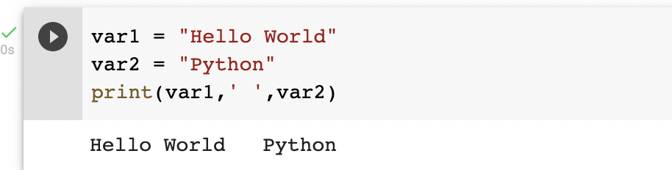

**Program 2**

**Objective:** code to print elements present at specific index value

var1 = "hello"

var2 = ""

print(var1[2])

print(var2[1:3])

**OUTPUT**

l

ub

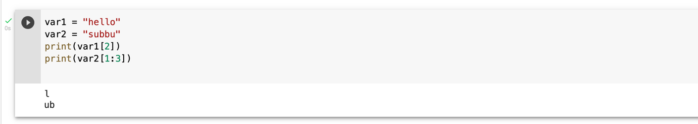

**Program 3**

**Objective:** To change the specific string value in python

var1 = "Good morning"

print("Updated String :- ", var1[0:5] + "subbu")

**OUTPUT**

Updated String :- Good subbu

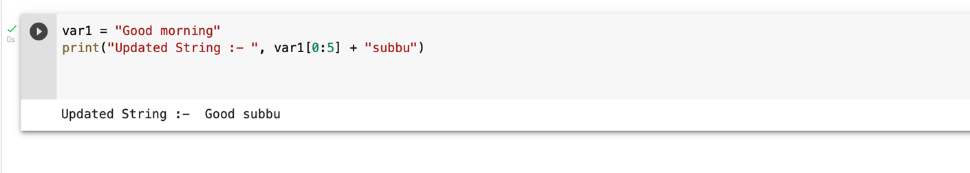

**Program 4**

**Objective:** To print the values present at given index location

str1 = input("Please enter your name : ")

str2=str1

str3=str1[:]

str4=str1[2:5]

print("Final name : str2 = ",str2)

print("Final name : str3 = ",str3)

print("Final name : str4 = = ",str4)

**OUTPUT**

Please enter your name : subbu

Final name : str2 = subbu

Final name : str3 = subbu

Final name : str4 = = bbu

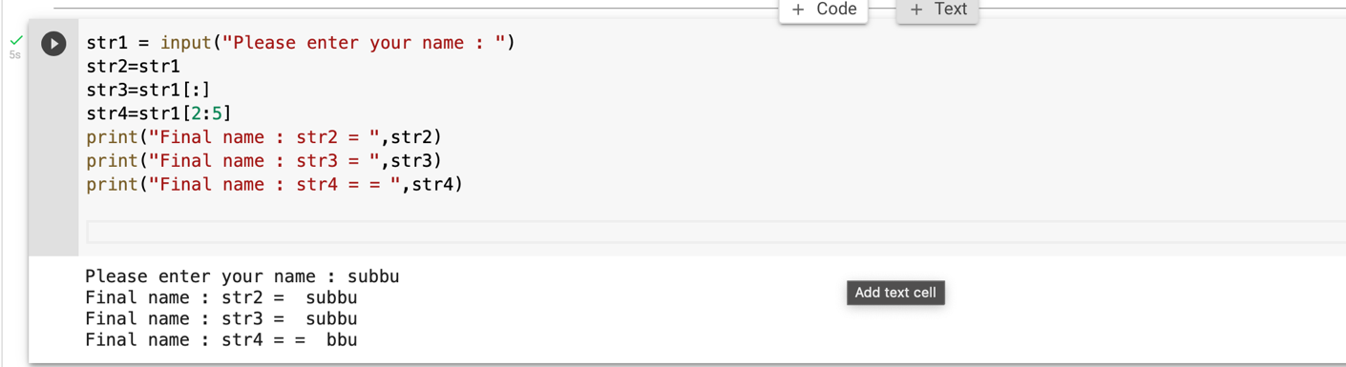

**Program 5**

**Objective:** Capitalize function in python which capitalizes only its first character.

### #Python String capitalize() method returns a copy of the string with on ly its first character capitalized.

str = "this is string example. wow!!!";

print ("str.capitalize() : ", str.capitalize())

**OUTPUT**

str.capitalize() : This is string example. wow!!!

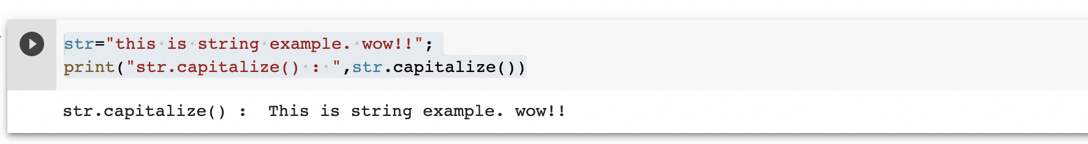

**Program 6**

**Objective:** To return centered in a string of length width. Padding is done using the specified fillchar. Default filler is a space.

### #center() returns centered in a string of length width. Padding is done using the specified fillchar. Default filler is a space.

str = "this is string example. wow!!!"

print ("str.center(40, 'a') : ", str.center(40, '*'))

str.center(40, 'a') : ****this is string example. wow!!!***

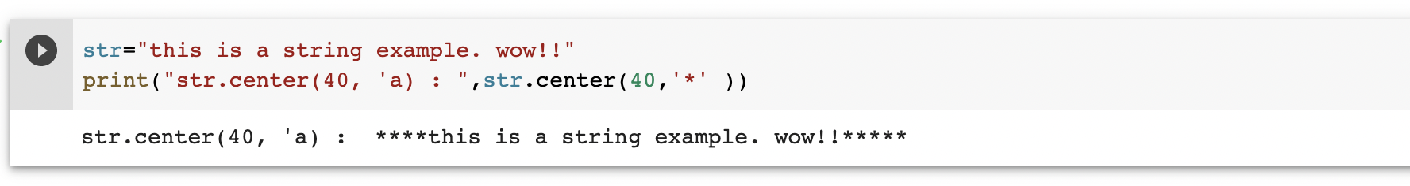

**Program 7**

**Objective:** To return the number of occurrences of substring sub in the range [start, end]

### #count() returns the number of occurrences of substring sub in the rang e [start, end].

#str.count(sub, start= 0,end=len(string))

str = "this is a string example.wow!!";

sub="i";

print("str.count(sub,4,40) : ",str.count(sub,4,40))

sub="wow";

print("str.count(sub) : ",str.count(sub))

**OUTPUT**

str.count(sub,4,40) : 2

str.count(sub) : 1

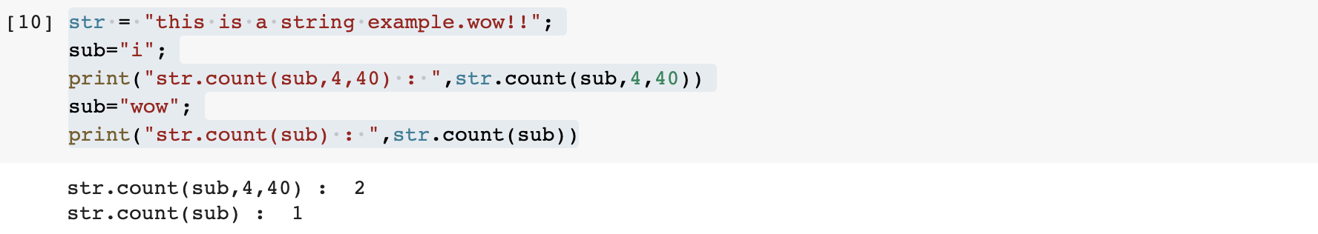

**Program 8**

**Objective:** To determine if string str occurs in string, or in a substring of string if starting index beg and ending index end are given.

### #find() determines if string str occurs in string, or in a substring of string if starting index beg and ending index end are given.

#str.find(str, beg=0, end=len(string))

str1 = "my name is subbu";

str2 = "my"

print(str1.find(str2))

print(str1.find(str2,10))

print(str1.find(str2,40))

**OUTPUT**

0

-1

-1

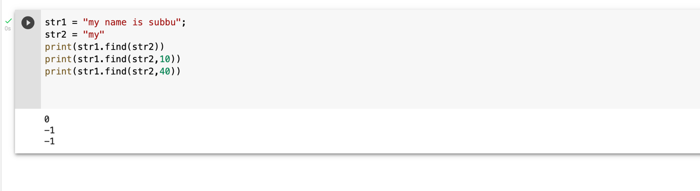

**Program 9**

**Objective:** To checks whether the string consists of alphanumeric characters.

### #isalnum() checks whether the string consists of alphanumeric character s.

str = "this2020"; # No space in this string print (str.isalnum())

str = "this is string example. subbu!!!";

print (str.isalnum())

**OUTPUT**

True False

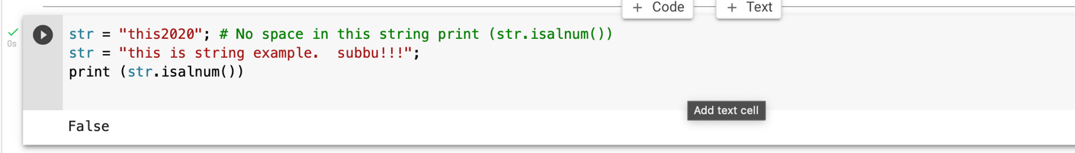

**Program 10**

**Objective:** To check whether string consist of alphabets and numbers without spaces using isalpha and isdigit.

str="kalyankumar";

print(str.isalpha())

str="this is example. hello";

print(str.isalpha())

True False

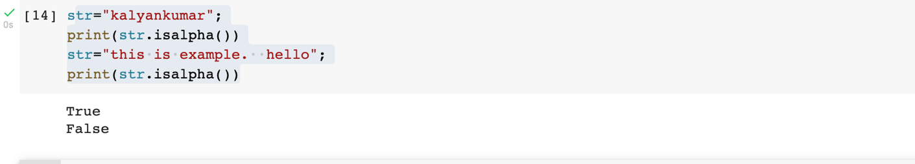

str="123345";

print(str.isdigit())

str="numbers";

print(str.isdigit())

**OUTPUT**

True False

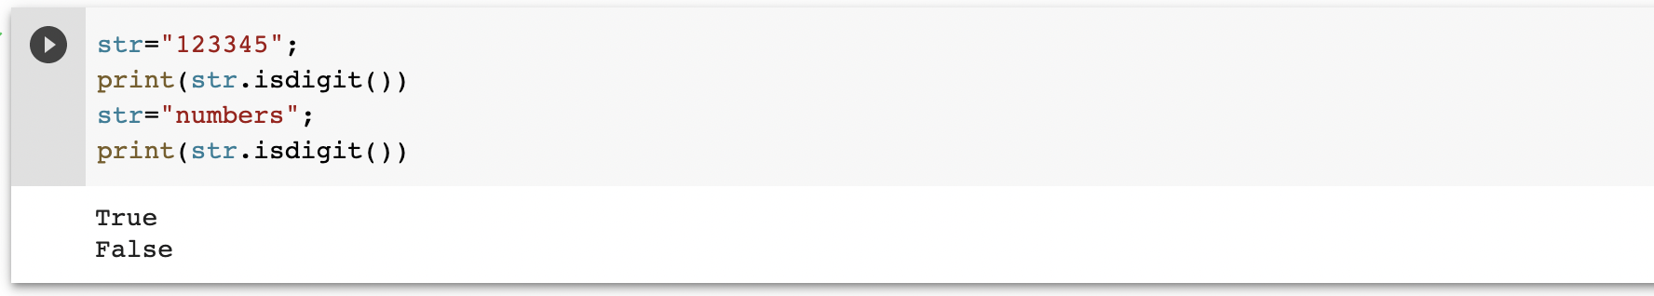

**Program 11**

### **Objective:** To check whether the string first letter is a small letter

str="My name is subbu";

print(str.islower())

str="my name is subbu";

print(str.islower())

OUTPUT

False True

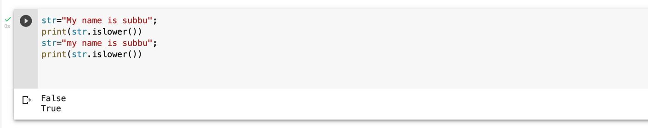

**Program 13**

**Objective:** To check whether strings every first character after space is capital using isnumeric and to check if all character in string is capitalized using issuper

### str = "this2009"; print (str.isnumeric())

str = "23443434";

print (str.isnumeric())

False True

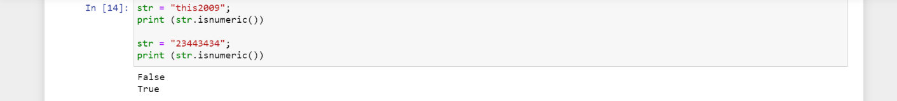

### str = " ";

print (str.isspace())

str = "This is string example. wow!!!";

print (str.isspace())

True False

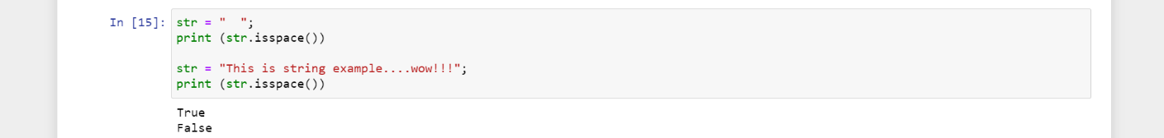

**Program 14**

**Objective:** To check whether strings every first character after space is capital using istitle and to check if all character in string is capitalized using isupper

### str = "This Is String Example...Wow!!!"; print (str.istitle())

str = "This is string example. wow!!!";

print (str.istitle())

True False

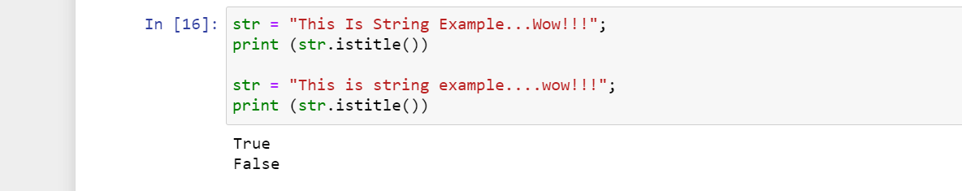

str = "THIS IS STRING EXAMPLE. WOW!!!";

print (str.isupper())

str = "THIS is string example. wow!!!";

print (str.isupper())

True False

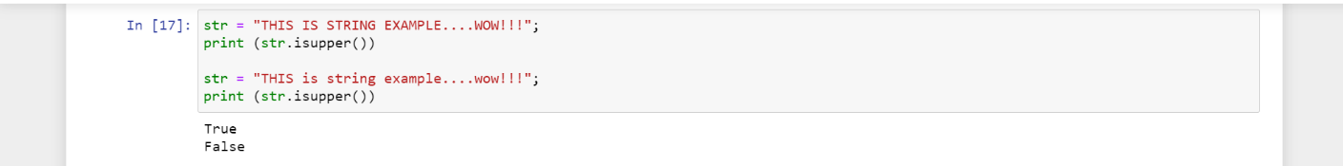

**Program 15**

**Objective:** To use join() function which returns a string in which the string elements of sequence have been joined by str separator.

### #join() returns a string in which the string elements of sequence have been joined by str separator.

s= " * * ";

seq = ("abc","bttt","fstty");

print(s.join(seq))

**OUTPUT**

abc * * bttt * * cqweqe abc * * bttt * * fstty

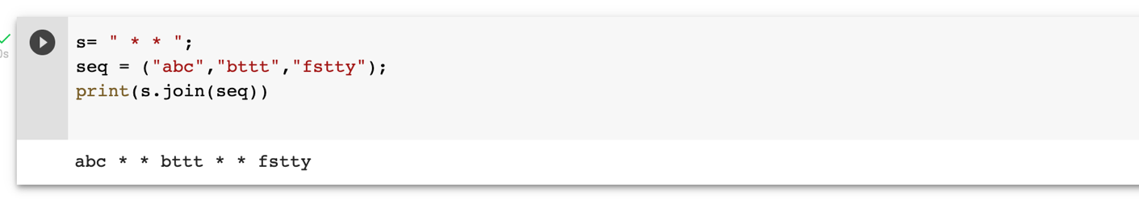

**Program 16**

**Objective:** To check for the length of string

str="My name is Kalyan";

print(str.islower())

str="my name is kalyan";

print(str.islower())

**OUTPUT**

Length of the string: 17

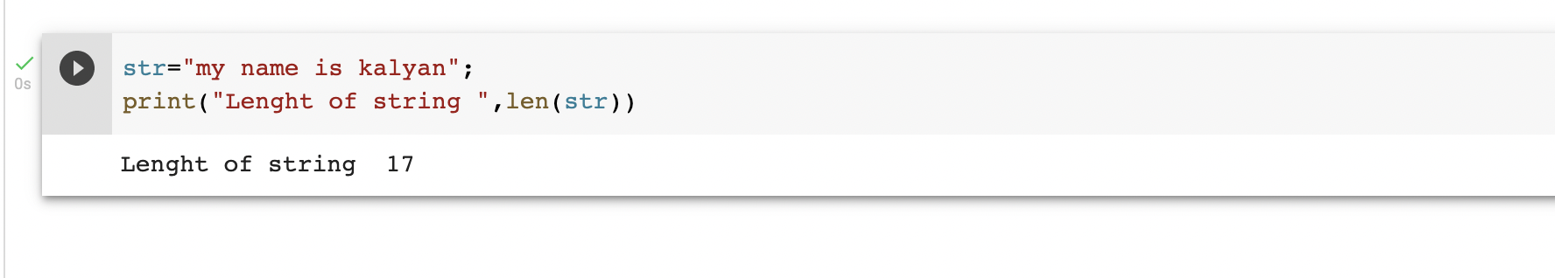

**Program 17**

**Objective:** To use istrip() function which returns a copy of the string in which all chars have been stripped from the beginning of the string (default whitespace characters)

### #lstrip() returns a copy of the string in which all chars have been str ipped from the beginning of the string (default whitespace characters)

str="my name is subramanyam";

print(str.lstrip())

str="6347317";

print(str.lstrip("8"))

print(str.lstrip("9"))

**OUTPUT**

my name is subramanyam

6347317

6347317

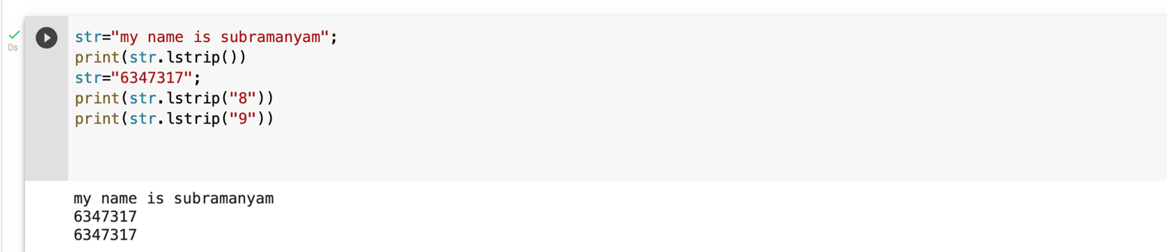

**Program 18**

**Objective:** To use lower () and capitalize function which convrts the string to lower and upper cases respectively

str="MY FULL NAME IS SUBRAMANYAM"

print(str.lower())

**OUTPUT**

my full name is subramanyam

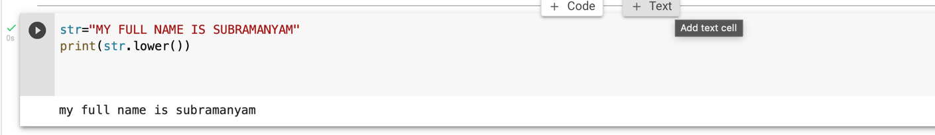

**Program 19**

**Objective:** To use max() function which returns largest character

### #returns largest character

tr="check. name";

print("Max character: "+ max(str))

str="kumar. !!";

print("Max character: " + max(str))

**OUTPUT**

Max character: n Max character: u

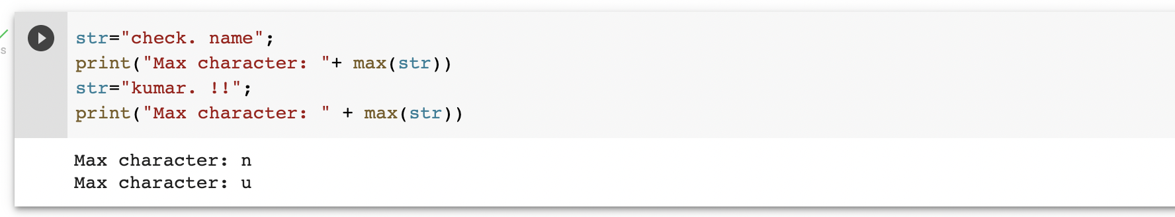

**Program 20**

**Objective:** To use min() function which returns smallest character

### str = "this-is-real-string-example wow!!!";

print ("Min character: " + min(str))

str = "this-is-a-string-example. wow!!!";

print ("Min character: " + min(str))

Min character: ! Min character: !

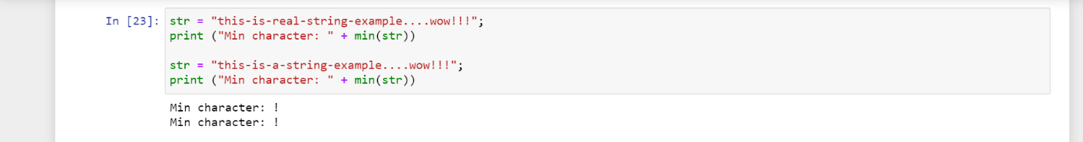

**Program 21**

**Objective:** To replace a certain character in string with another character

### #str.replace(old, new[, max])

str="my name is subbutarak";

print(str.replace("subbu","tarak"))

print(str.replace("subbu","tarak",5))

**OUTPUT**

my name is taraktarak

my name is taraktarak

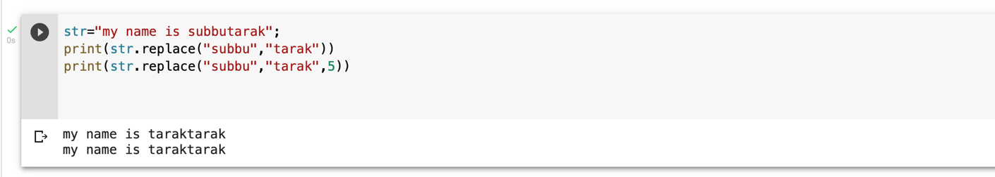

str="my name subramanyam";

print(str.startswith('my'))

print(str.startswith('name',2,4))

print(str.startswith('name',2,2))

True True

False

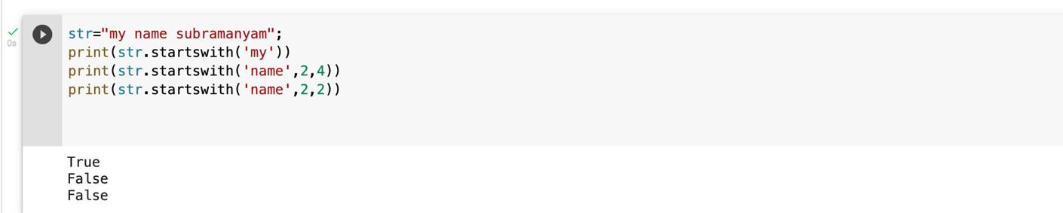

str="my name kalyan";

print("str.capitalize() : ", str.upper())

str.capitalize() : MY NAME SUBBU

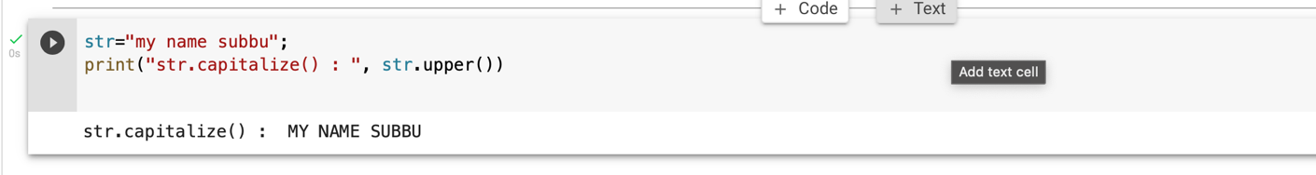

str="my full name is Subbu tarak";

print(str.swapcase())

MY FULL NAME IS SUBBU TARAK

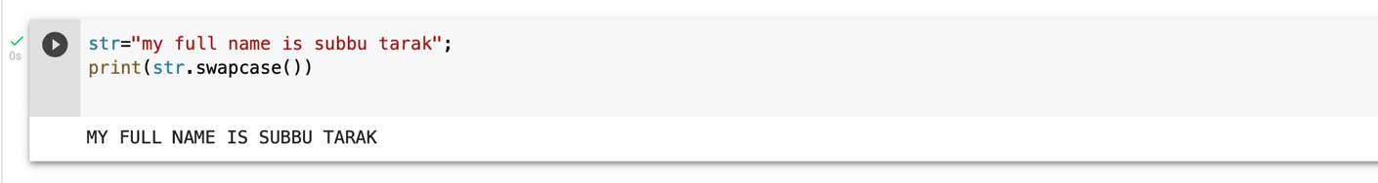

# LISTS

list1 = ['english', 'maths', 2001, 2020];

list2 = [1,3,4,2,5,2,4 ];

print ("list1[0]: ", list1[2])

print ("list2[1:5]: ", list2[1:3])

list1[0]: 2001

list2[1:5]: [3, 4]

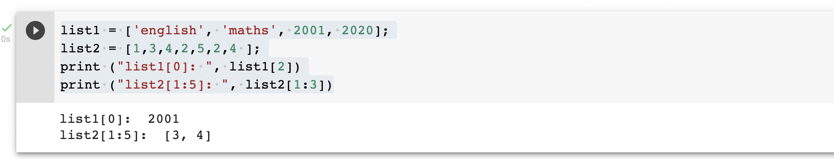

list = ['English', 'hindi', 2020, 1990];

print ("Value available at index 3 : ")

print (list[2])

list[2] = 2344323;

print ("New value available at index 3: ")

print (list[2])

Value available at index 3 :

2020

New value available at index 3:

2344323

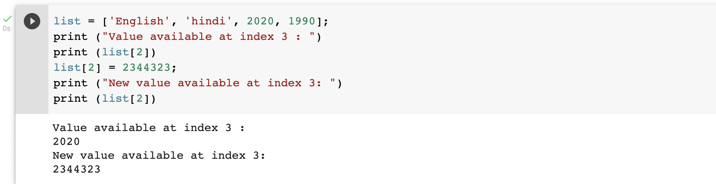

list1 = ['Social', 'maths', 'computers', 2000];

print (list1)

del (list1[2]);

print ("After deleting value at index 3 :")

print (list1)

['Social', 'maths', 'computers', 2000]

After deleting value at index 3 :

['Social', 'maths', 2000]

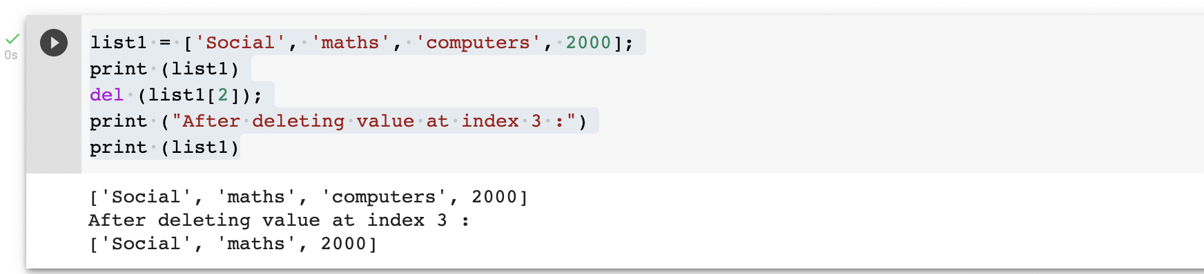

list1, list2 = ['subbu','345','subbu'], [345, 'tarak']

print ("First list length : ", len(list1))

print ("Second list length : ", len(list2))

First list length : 3

Second list length : 2

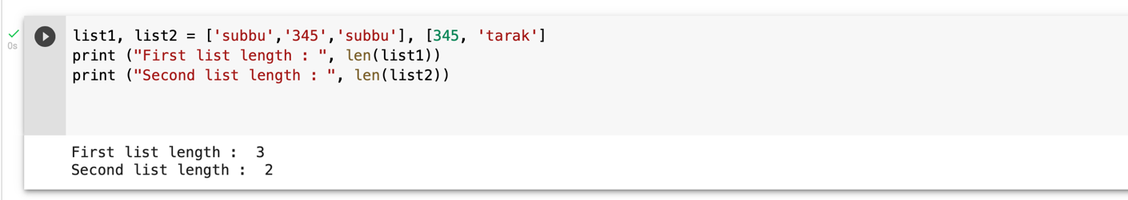

aList = ['subbu', 'tarak’, 'subbu'];

aList.append( 2019 );

print ("Updated List : ", aList)

Updated List : ['subbu', 'tarak', 'subbu', 2019]

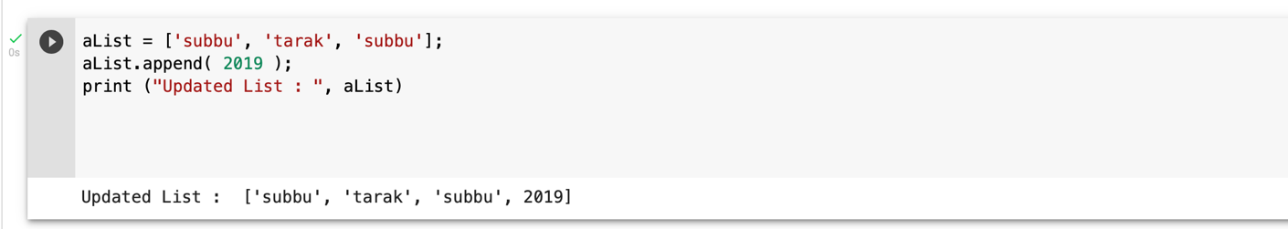

aList = ['subbu', 'tarak', 'subbu’, 234];

print ("Count for xyz : ", aList.count('subbu'))

print ("Count for zara : ", aList.count('tarak'))

Count for xyz : 1

Count for zara : 1

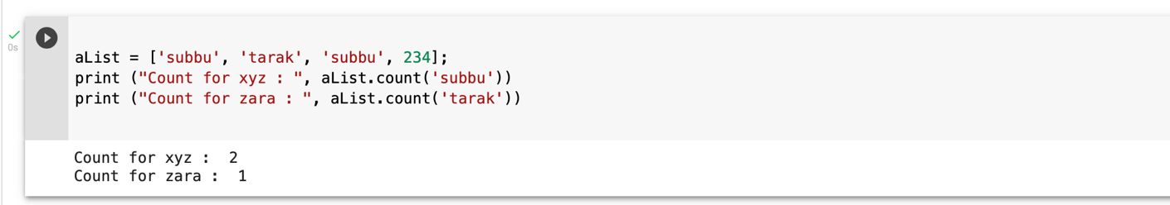

aList = [234, 'tarak', 'subbu', 'tarak', 123];

bList = [2009, 'subbu'];

aList.extend(bList)

print ("Extended List : ", aList)

Extended List : [234, 'tarak', 'subbu', 'tarak', 123, 2009, 'subbu']

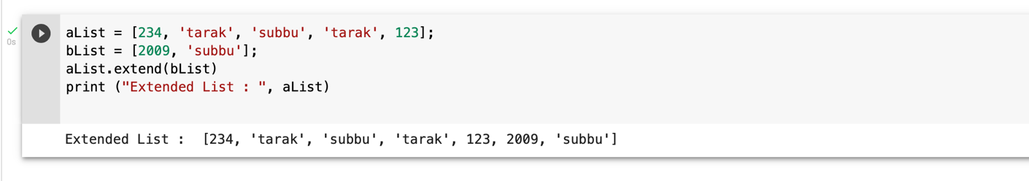

aList = [123, 'subbu', 'tarak', 'subbu', 'tarak'];

print ("Index for xyz : ", aList.index( 'subbu' ) )

print ("Index for zara : ", aList.index( 'tarak' ) )

Index for xyz : 3

Index for zara : 2

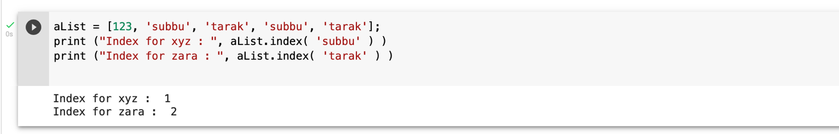

aList = [123, 'hindi', 'social', 'maths']

aList.insert( 2,2000)

print ("Final List : ", aList)

Final List : [123, 'hindi', 2000, 'social', 'maths']

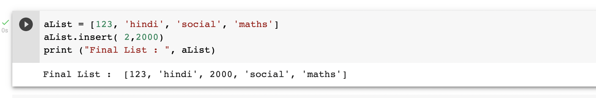

aList = [123, 'subbu', 'tarak', 'subbu'];

print(aList)

print ("List after popping last element : ", aList.pop())

print(aList)

print ("List after popping element from mentioned index: ", aList.pop(2))

print(aList)

aList.insert(3, 2020)

print(aList)

[123, 'subbu', 'tarak', 'subbu']

List after popping last element : subbu

[123, 'subbu', 'tarak']

List after popping element from mentioned index: tarak

[123, 'subbu']

[123, 'subbu', 2020]

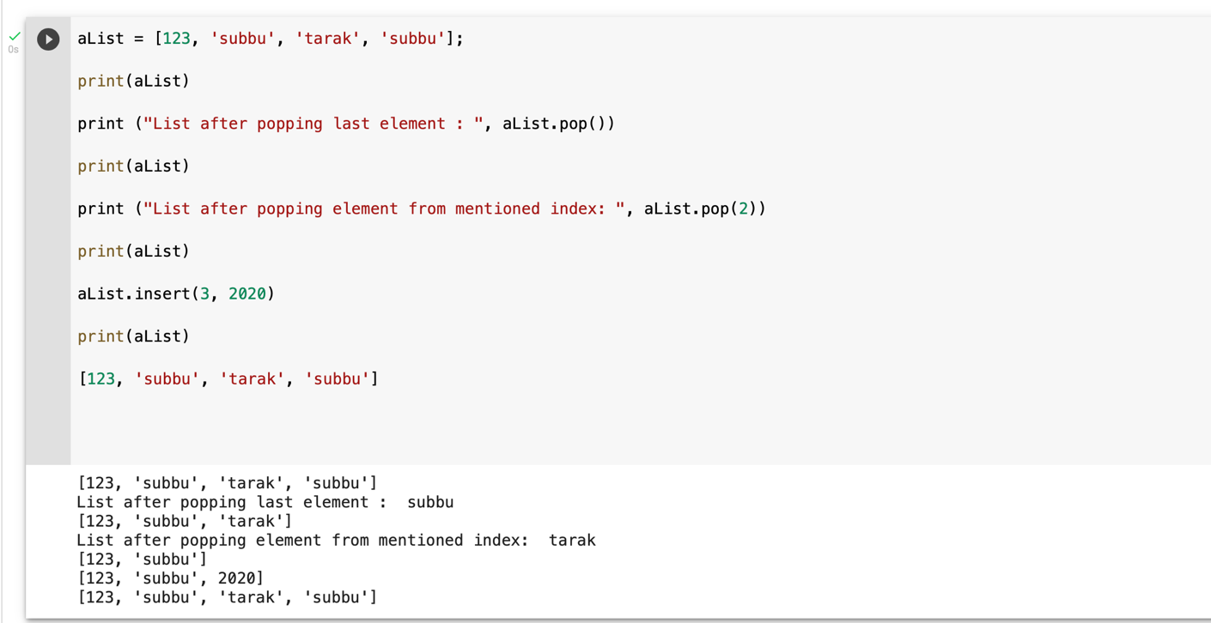

aList = [123, 'subbu', 'zara', 'tarak', 'xyz'];

aList.remove('xyz');

print ("List : ", aList)

aList.remove('subbu');

print ("List : ", aList)

List : [123, 'subbu', 'zara', 'tarak']

List : [123, 'zara', 'tarak']

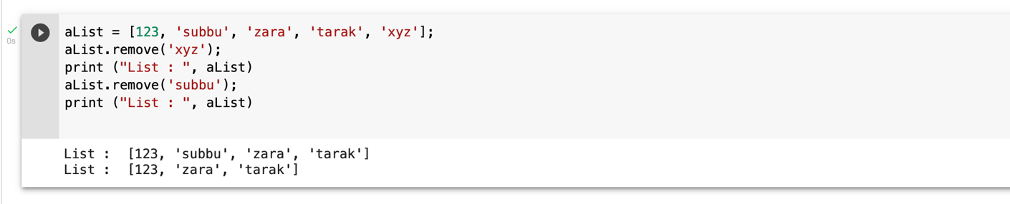

aList = ['subbu', 'tarak', 'subbu', 'tarak', 'sandeep'];

aList.reverse();

print ("List : ", aList)

List : ['sandeep', 'tarak', 'subbu', 'tarak', 'subbu']

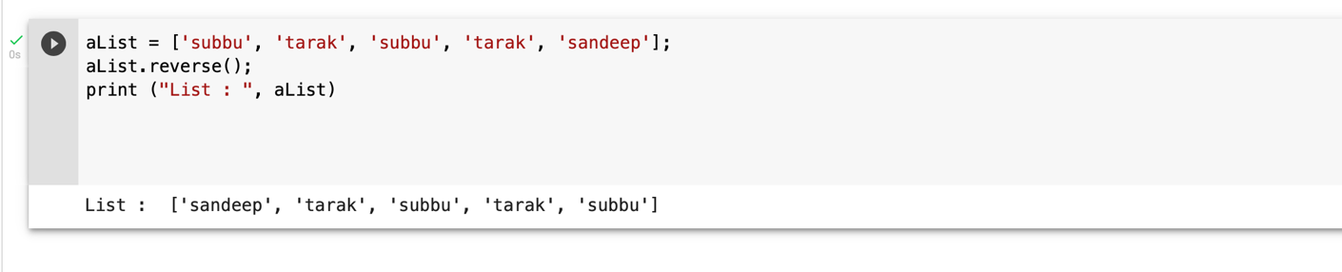

aList = ['kalyan', 'kuamr', 'reddy', 'siva', 'subbu'];

aList.sort();

print ("List : ", aList)

List : ['kalyan', 'kuamr', 'reddy', 'siva', 'subbu']

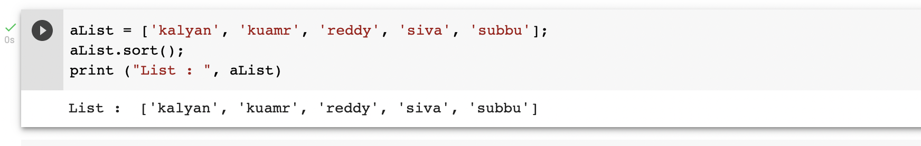

**LOOPS**

### str = "Python" for i in str:

print(i)

P

y t h o n

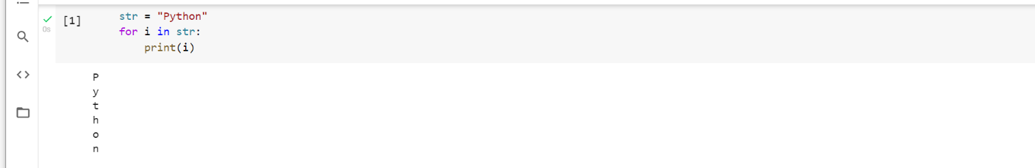

### list = [1,2,3,4,5,6,7,8,9,10]

n = 6

for i in list: c = n*i

print(n," *",i, " =", c)

|  |  |
| --- | --- |
| 6 | * 1 = 6 |
| 6 | * 2 = 12 |
| 6 | * 3 = 18 |
| 6 | * 4 = 24 |
| 6 | * 5 = 30 |
| 6 | * 6 = 36 |
| 6 | * 7 = 42 |
| 6 | * 8 = 48 |
| 6 | * 9 = 54 |
| 6 | * 10 = 60 |
|  |  |

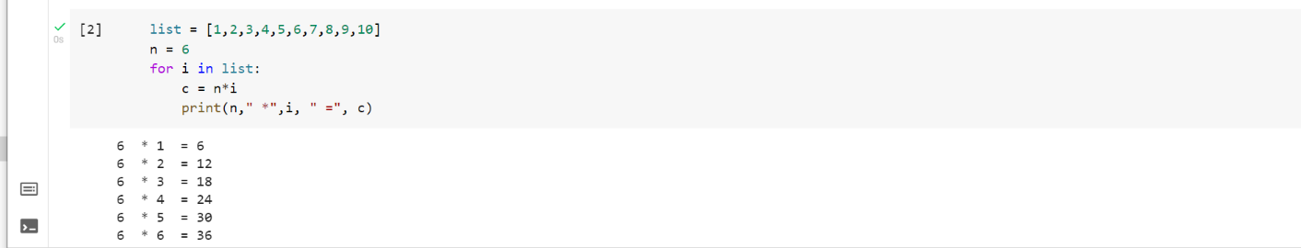

list = [10,30,23,43,65,12]

sum = 0

for i in list: sum = sum+i

print("The sum is:",sum)

The sum is: 183

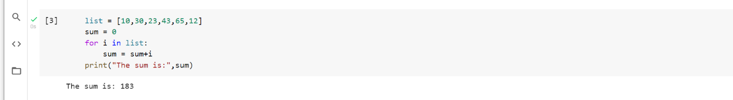

### for i in range(14):

print(i,end=' ')

0 1 2 3 4 5 6 7 8 9 10 11 12 13

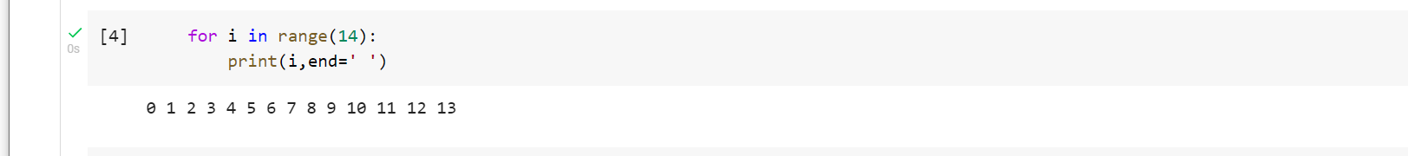

n = int(input("Enter the number "))

for i in range(1,11):

c = n*i

print(n,"*",i,"=",c)

Enter the number 23

23 * 1 = 23

23 * 2 = 46

23 * 3 = 69

23 * 4 = 92

23 * 5 = 115

23 * 6 = 138

23 * 7 = 161

23 * 8 = 184

23 * 9 = 207

23 * 10 = 230

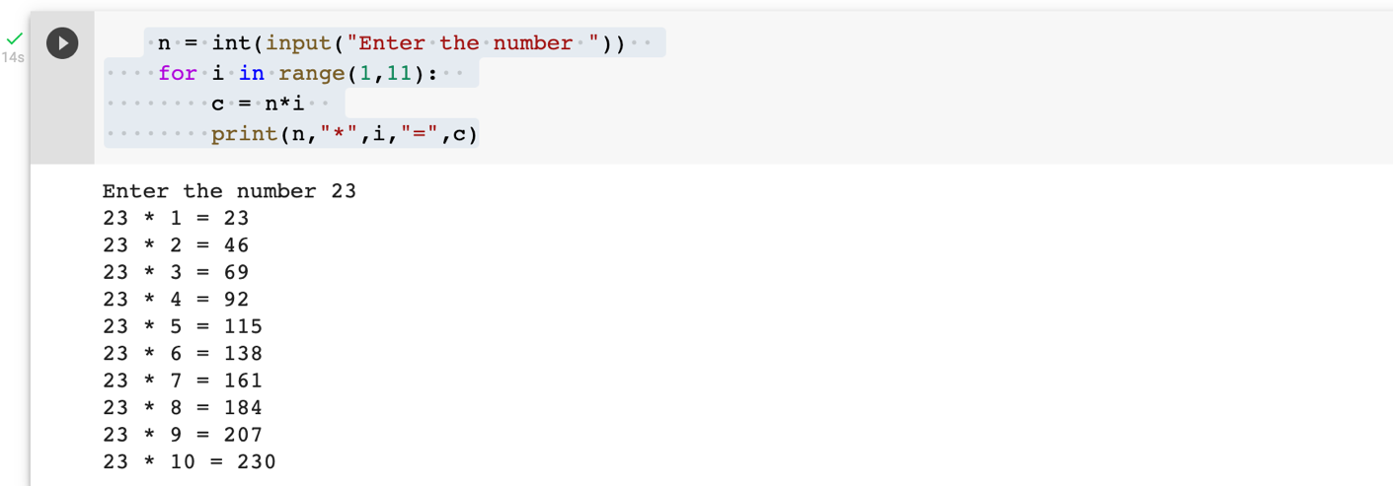

### n = int(input("Enter the number ")) for i in range(2,n,2):

print(i)

Enter the number 19 2

4

6

8

10

12

14

16

18

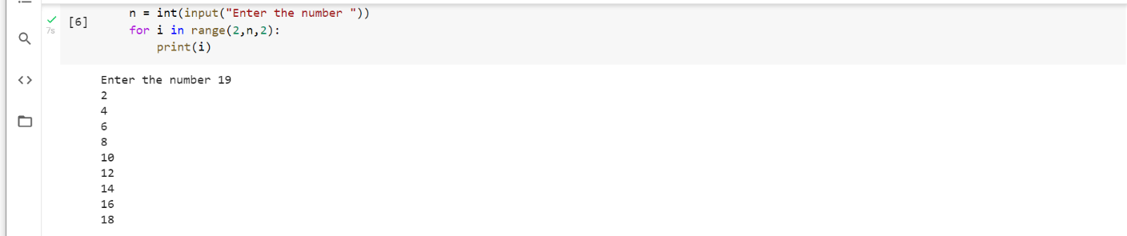

list = ['kalyan','Subbu','shiridi','anil']

for i in range(len(list)):

print("Hello",list[i])

Hello kalyan

Hello Subbu

Hello shiridi

Hello anil

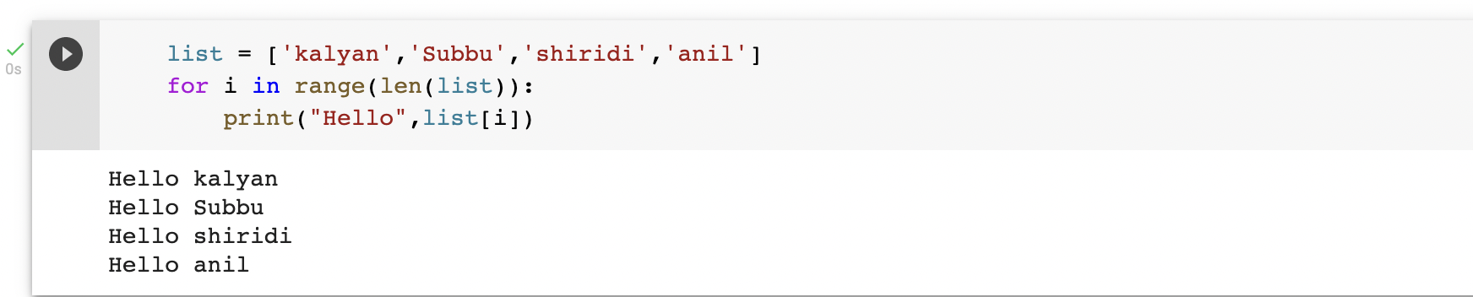

### for i in range(0,7):

print(i)

else:

print("for loop completely exhausted, since there is no break."

)

0

1

2

3

4

5

6

for loop completely exhausted, since there is no break.

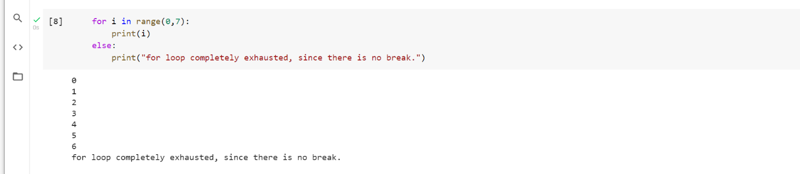



### for i in range(0,7):

print(i) print("bye") continue; print("hello")

else:print("for loop is exhausted");

print("The loop is broken due to break statement...came out of the loop")

0

bye 1

bye 2

bye 3

bye 4

bye 5

bye 6

bye

for loop is exhausted

The loop is broken due to break statement...came out of the loop

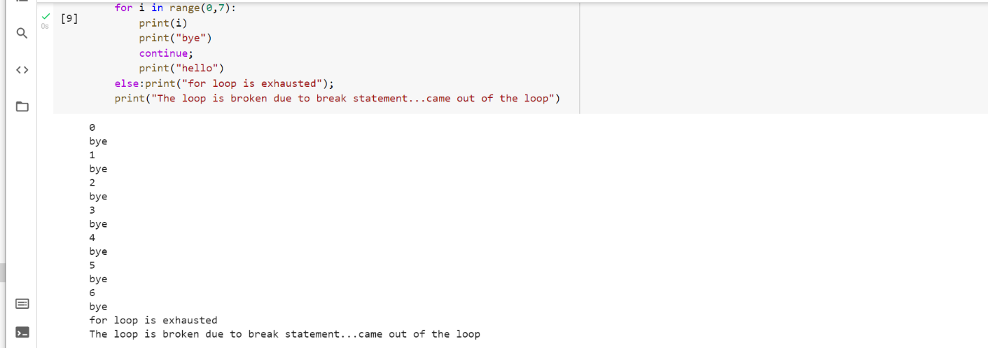

### # prints all letters except 'a' and 't' i = 0

str1 = 'shabnam' print(str1)

while i < len(str1):

print('entered while loop before if statement') if str1[i] == 'a' or str1[i] == 'u':

print('entered if statement') i += 1

print('i incremented') continue

print('after continue')

print('Current Letter :', str1[i])

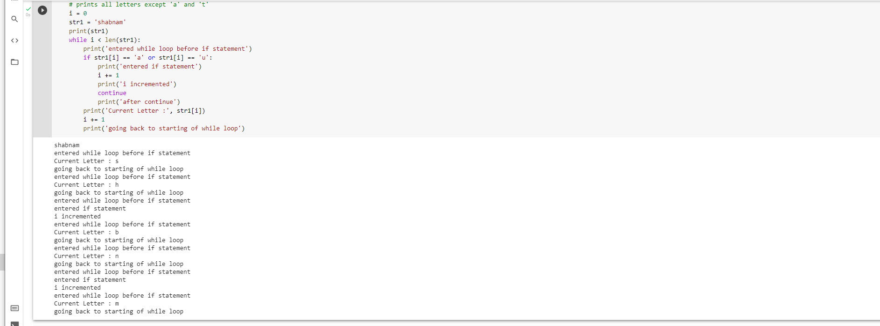

# prints all letters except 'a' and 't'

i = 0

str1 = 'subbu'

print(str1)

while i < len(str1):

print('entered while loop before if statement')

if str1[i] == 'a' or str1[i] == 'u':

print('entered if statement')

i += 1

print('i incremented')

continue

print('after continue')

print('Current Letter :', str1[i])

i += 1

print('going back to starting of while loop')

subbu

entered while loop before if statement

Current Letter : k

going back to starting of while loop

entered while loop before if statement

entered if statement

i incremented

entered while loop before if statement

Current Letter : l

going back to starting of while loop

entered while loop before if statement

Current Letter : y

going back to starting of while loop

entered while loop before if statement

entered if statement

i incremented

entered while loop before if statement

Current Letter : n

going back to starting of while loop

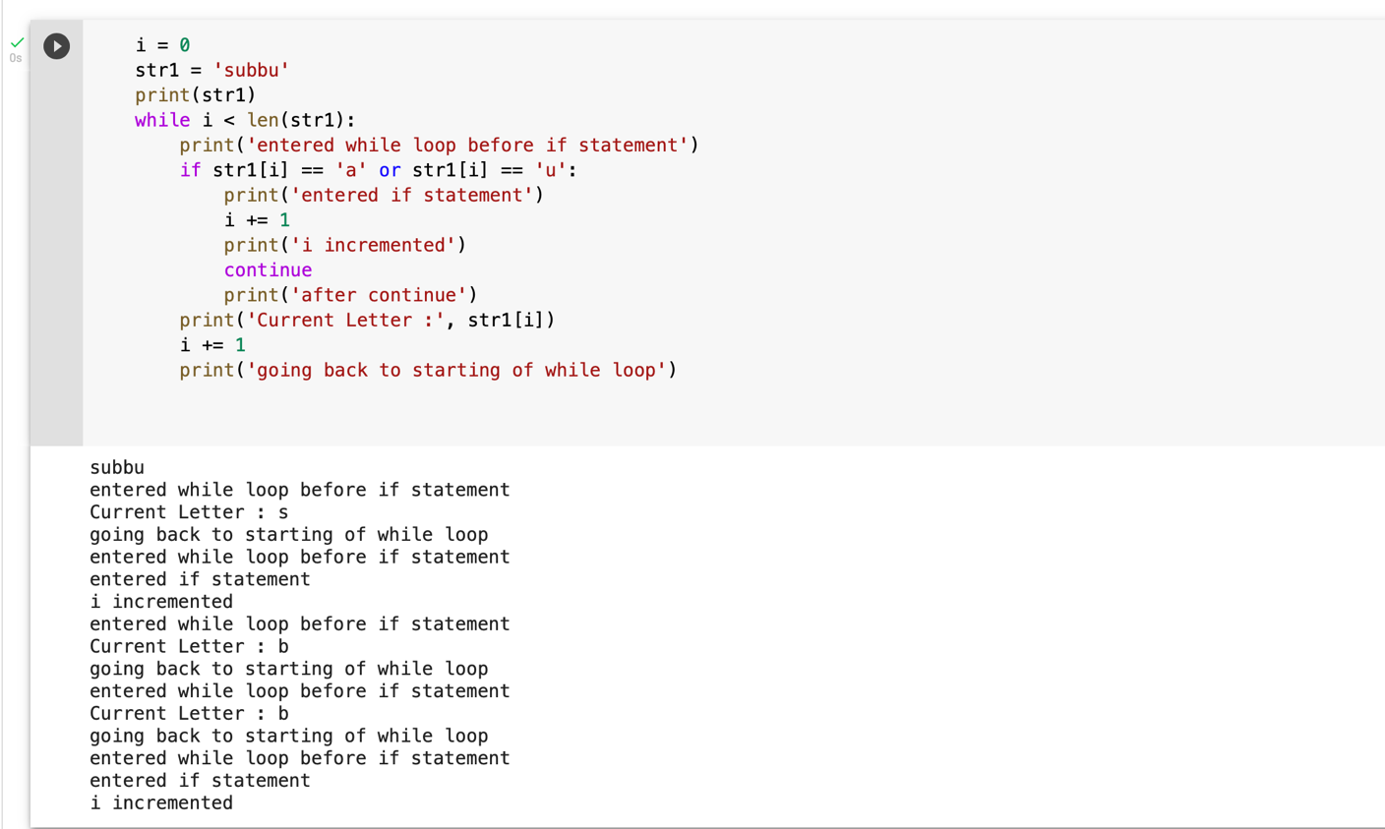

### #The pass statement is used to declare the empty loop.

#It is also used to define empty class, function, and control statement

.

i = 0

str1 = 'subbu'

while i < len(str1):

if str1[i] == 'n':

i += 1

break

print('Current Letter :', str1[i])

i += 1

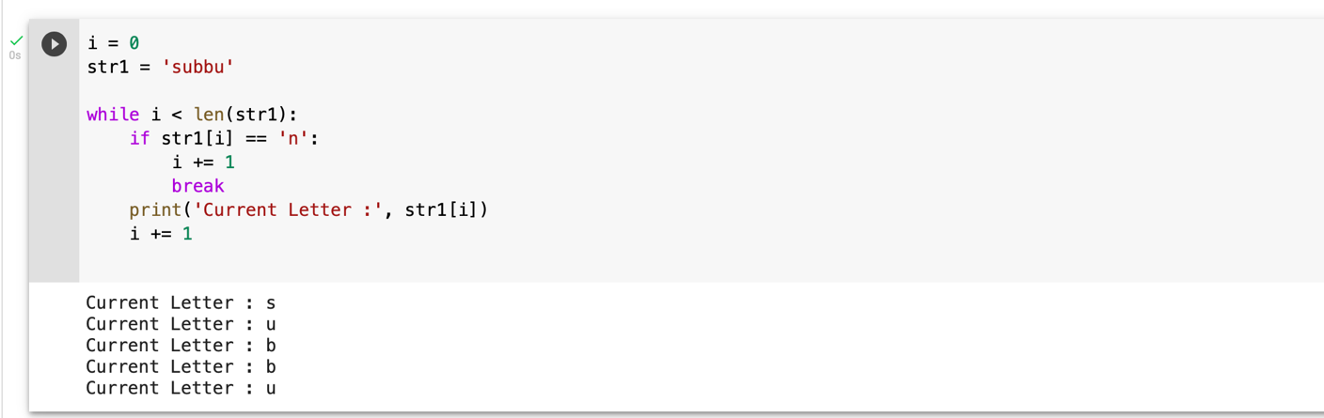

Current Letter : s

Current Letter : u

Current Letter : b

Current Letter : b

Current Letter : u

#The pass statement is used to declare the empty loop.

#It is also used to define empty class, function, and control statement.

str1 = 'subbu'

i = 0

while i < len(str1):

i += 1

pass

print('Value of i :', i)

Value of i : 5

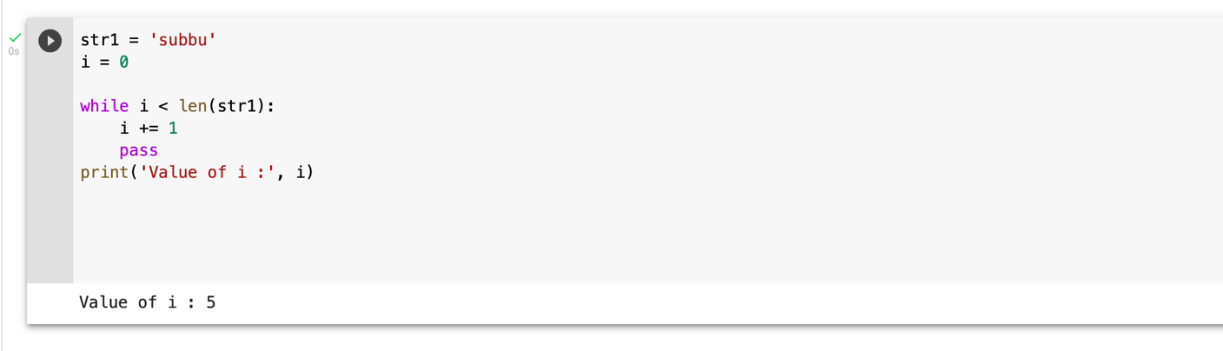

i=1

#The while loop will iterate until condition becomes false.

while(i<=10):

print(i)

i=i+1

1

2

3

4

5

6

7

8

9

10

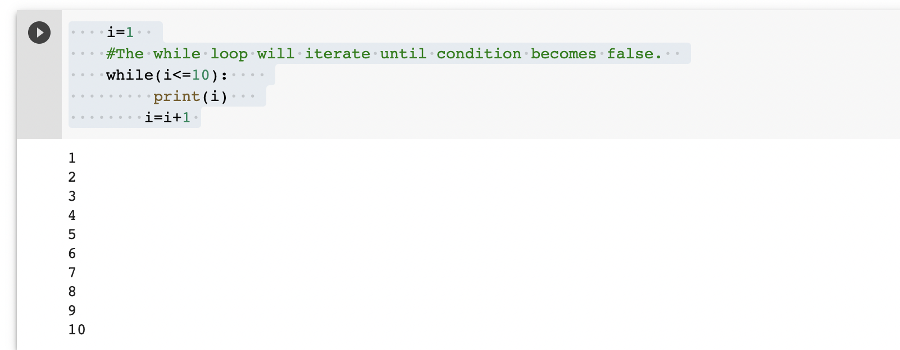

### i=1

number = int(input("Enter the number:")) while i<=10:

print("%d X %d = %d \n"%(number,i,number*i)) i = i+1

Enter the number:3

|  |  |  |  |  |
| --- | --- | --- | --- | --- |
| 3 | X | 1 | = | 3 |
| 3 | X | 2 | = | 6 |
| 3 | X | 3 | = | 9 |
| 3 | X | 4 | = | 12 |
| 3 | X | 5 | = | 15 |
| 3 | X | 6 | = | 18 |
| 3 | X | 7 | = | 21 |
| 3 | X | 8 | = | 24 |
| 3 | X | 9 | = | 27 |

3 X 10 = 30

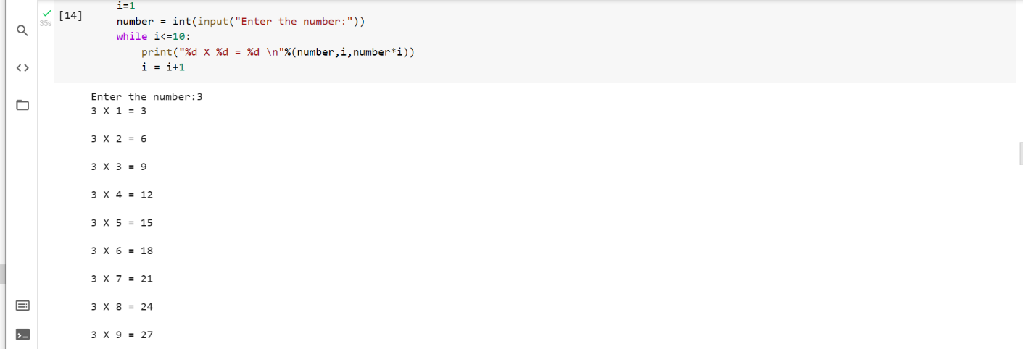

while (1):

print("Hi! we are inside the infinite while loop")

Hi! we are inside the infinite while loop Hi! we are inside the infinite while loop Hi! we are inside the infinite while loop Hi! we are inside the infinite while loop Hi! we are inside the infinite while loop Hi! we are inside the infinite while loop Hi! we are inside the infinite while loop Hi! we are inside the infinite while loop Hi! we are inside the infinite while loop Hi! we are inside the infinite while loop Hi! we are inside the infinite while loop Hi! we are inside the infinite while loop Hi! we are inside the infinite while loop Hi! we are inside the infinite while loop Hi! we are inside the infinite while loop Hi! we are inside the infinite while loop Hi! we are inside the infinite while loop Hi! we are inside the infinite while loop Hi! we are inside the infinite while loop Hi! we are inside the infinite while loop Hi! we are inside the infinite while loop Hi! we are inside the infinite while loop Hi! we are inside the infinite while loop Hi! we are inside the infinite while loop Hi! we are inside the infinite while loop Hi! we are inside the infinite while loop Hi! we are inside the infinite while loop Hi! we are inside the infinite while loop Hi! we are inside the infinite while loop Hi! we are inside the infinite while loop Hi! we are inside the infinite while loop Hi! we are inside the infinite while loop Hi! we are inside the infinite while loop Hi! we are inside the infinite while loop Hi! we are inside the infinite while loop Hi! we are inside the infinite while loop Hi! we are inside the infinite while loop Hi! we are inside the infinite while loop Hi! we are inside the infinite while loop Hi! we are inside the infinite while loop Hi! we are inside the infinite while loop Hi! we are inside the infinite while loop Hi! we are inside the infinite while loop Hi! we are inside the infinite while loop Hi! we are inside the infinite while loop Hi! we are inside the infinite while loop Hi! we are inside the infinite while loop Hi! we are inside the infinite while loop Hi! we are inside the infinite while loop Hi! we are inside the infinite while loop Hi! we are inside the infinite while loop Hi! we are inside the infinite while loop Hi! we are inside the infinite while loop Hi! we are inside the infinite while loop Hi! we are inside the infinite while loop Hi! we are inside the infinite while loop Hi! we are inside the infinite while loop Hi! we are inside the infinite while loop Hi! we are inside the infinite while loop Hi! we are inside the infinite while loop Hi! we are inside the infinite while loop

Hi! we are inside the infinite while loop Hi! we are inside the infinite while loop Hi! we are inside the infinite while loop Hi! we are inside the infinite while loop Hi! we are inside the infinite while loop Hi! we are inside the infinite while loop Hi! we are inside the infinite while loop Hi! we are inside the infinite while loop Hi! we are inside the infinite while loop Hi! we are inside the infinite while loop Hi! we are inside the infinite while loop Hi! we are inside the infinite while loop Hi! we are inside the infinite while loop Hi! we are inside the infinite while loop Hi! we are inside the infinite while loop Hi! we are inside the infinite while loop Hi! we are inside the infinite while loop Hi! we are inside the infinite while loop Hi! we are inside the infinite while loop Hi! we are inside the infinite while loop Hi! we are inside the infinite while loop Hi! we are inside the infinite while loop Hi! we are inside the infinite while loop Hi! we are inside the infinite while loop Hi! we are inside the infinite while loop Hi! we are inside the infinite while loop Hi! we are inside the infinite while loop Hi! we are inside the infinite while loop Hi! we are inside the infinite while loop Hi! we are inside the infinite while loop Hi! we are inside the infinite while loop Hi! we are inside the infinite while loop Hi! we are inside the infinite while loop Hi! we are inside the infinite while loop Hi! we are inside the infinite while loop Hi! we are inside the infinite while loop Hi! we are inside the infinite while loop Hi! we are inside the infinite while loop Hi! we are inside the infinite while loop Hi! we are inside the infinite while loop Hi! we are inside the infinite while loop Hi! we are inside the infinite while loop Hi! we are inside the infinite while loop Hi! we are inside the infinite while loop Hi! we are inside the infinite while loop Hi! we are inside the infinite while loop Hi! we are inside the infinite while loop Hi! we are inside the infinite while loop Hi! we are inside the infinite while loop Hi! we are inside the infinite while loop Hi! we are inside the infinite while loop Hi! we are inside the infinite while loop Hi! we are inside the infinite while loop Hi! we are inside the infinite while loop Hi! we are inside the infinite while loop Hi! we are inside the infinite while loop Hi! we are inside the infinite while loop Hi! we are inside the infinite while loop Hi! we are inside the infinite while loop Hi! we are inside the infinite while loop Hi! we are inside the infinite while loop

Hi! we are inside the infinite while loop Hi! we are inside the infinite while loop Hi! we are inside the infinite while loop Hi! we are inside the infinite while loop Hi! we are inside the infinite while loop Hi! we are inside the infinite while loop Hi! we are inside the infinite while loop Hi! we are inside the infinite while loop Hi! we are inside the infinite while loop Hi! we are inside the infinite while loop Hi! we are inside the infinite while loop Hi! we are inside the infinite while loop Hi! we are inside the infinite while loop Hi! we are inside the infinite while loop Hi! we are inside the infinite while loop Hi! we are inside the infinite while loop Hi! we are inside the infinite while loop Hi! we are inside the infinite while loop Hi! we are inside the infinite while loop Hi! we are inside the infinite while loop Hi! we are inside the infinite while loop Hi! we are inside the infinite while loop Hi! we are inside the infinite while loop Hi! we are inside the infinite while loop Hi! we are inside the infinite while loop Hi! we are inside the infinite while loop Hi! we are inside the infinite while loop Hi! we are inside the infinite while loop Hi! we are inside the infinite while loop Hi! we are inside the infinite while loop Hi! we are inside the infinite while loop Hi! we are inside the infinite while loop Hi! we are inside the infinite while loop Hi! we are inside the infinite while loop Hi! we are inside the infinite while loop Hi! we are inside the infinite while loop Hi! we are inside the infinite while loop Hi! we are inside the infinite while loop Hi! we are inside the infinite while loop Hi! we are inside the infinite while loop Hi! we are inside the infinite while loop Hi! we are inside the infinite while loop Hi! we are inside the infinite while loop Hi! we are inside the infinite while loop Hi! we are inside the infinite while loop Hi! we are inside the infinite while loop Hi! we are inside the infinite while loop Hi! we are inside the infinite while loop Hi! we are inside the infinite while loop Hi! we are inside the infinite while loop Hi! we are inside the infinite while loop Hi! we are inside the infinite while loop Hi! we are inside the infinite while loop Hi! we are inside the infinite while loop Hi! we are inside the infinite while loop Hi! we are inside the infinite while loop Hi! we are inside the infinite while loop Hi! we are inside the infinite while loop Hi! we are inside the infinite while loop Hi! we are inside the infinite while loop Hi! we are inside the infinite while loop

Hi! we are inside the infinite while loop Hi! we are inside the infinite while loop Hi! we are inside the infinite while loop Hi! we are inside the infinite while loop Hi! we are inside the infinite while loop Hi! we are inside the infinite while loop Hi! we are inside the infinite while loop Hi! we are inside the infinite while loop Hi! we are inside the infinite while loop Hi! we are inside the infinite while loop Hi! we are inside the infinite while loop Hi! we are inside the infinite while loop Hi! we are inside the infinite while loop Hi! we are inside the infinite while loop Hi! we are inside the infinite while loop Hi! we are inside the infinite while loop Hi! we are inside the infinite while loop Hi! we are inside the infinite while loop Hi! we are inside the infinite while loop Hi! we are inside the infinite while loop Hi! we are inside the infinite while loop Hi! we are inside the infinite while loop Hi! we are inside the infinite while loop Hi! we are inside the infinite while loop Hi! we are inside the infinite while loop Hi! we are inside the infinite while loop Hi! we are inside the infinite while loop Hi! we are inside the infinite while loop Hi! we are inside the infinite while loop Hi! we are inside the infinite while loop Hi! we are inside the infinite while loop Hi! we are inside the infinite while loop Hi! we are inside the infinite while loop Hi! we are inside the infinite while loop Hi! we are inside the infinite while loop Hi! we are inside the infinite while loop Hi! we are inside the infinite while loop Hi! we are inside the infinite while loop Hi! we are inside the infinite while loop Hi! we are inside the infinite while loop Hi! we are inside the infinite while loop Hi! we are inside the infinite while loop Hi! we are inside the infinite while loop Hi! we are inside the infinite while loop Hi! we are inside the infinite while loop Hi! we are inside the infinite while loop Hi! we are inside the infinite while loop Hi! we are inside the infinite while loop Hi! we are inside the infinite while loop Hi! we are inside the infinite while loop Hi! we are inside the infinite while loop Hi! we are inside the infinite while loop Hi! we are inside the infinite while loop Hi! we are inside the infinite while loop Hi! we are inside the infinite while loop Hi! we are inside the infinite while loop Hi! we are inside the infinite while loop Hi! we are inside the infinite while loop Hi! we are inside the infinite while loop Hi! we are inside the infinite while loop Hi! we are inside the infinite while loop

Hi! we are inside the infinite while loop Hi! we are inside the infinite while loop Hi! we are inside the infinite while loop Hi! we are inside the infinite while loop Hi! we are inside the infinite while loop Hi! we are inside the infinite while loop Hi! we are inside the infinite while loop Hi! we are inside the infinite while loop Hi! we are inside the infinite while loop Hi! we are inside the infinite while loop Hi! we are inside the infinite while loop Hi! we are inside the infinite while loop Hi! we are inside the infinite while loop Hi! we are inside the infinite while loop Hi! we are inside the infinite while loop Hi! we are inside the infinite while loop Hi! we are inside the infinite while loop Hi! we are inside the infinite while loop Hi! we are inside the infinite while loop Hi! we are inside the infinite while loop Hi! we are inside the infinite while loop Hi! we are inside the infinite while loop Hi! we are inside the infinite while loop Hi! we are inside the infinite while loop Hi! we are inside the infinite while loop Hi! we are inside the infinite while loop Hi! we are inside the infinite while loop Hi! we are inside the infinite while loop Hi! we are inside the infinite while loop Hi! we are inside the infinite while loop Hi! we are inside the infinite while loop Hi! we are inside the infinite while loop Hi! we are inside the infinite while loop Hi! we are inside the infinite while loop Hi! we are inside the infinite while loop Hi! we are inside the infinite while loop Hi! we are inside the infinite while loop Hi! we are inside the infinite while loop Hi! we are inside the infinite while loop Hi! we are inside the infinite while loop Hi! we are inside the infinite while loop Hi! we are inside the infinite while loop Hi! we are inside the infinite while loop Hi! we are inside the infinite while loop Hi! we are inside the infinite while loop Hi! we are inside the infinite while loop Hi! we are inside the infinite while loop Hi! we are inside the infinite while loop Hi! we are inside the infinite while loop Hi! we are inside the infinite while loop Hi! we are inside the infinite while loop Hi! we are inside the infinite while loop Hi! we are inside the infinite while loop Hi! we are inside the infinite while loop Hi! we are inside the infinite while loop Hi! we are inside the infinite while loop Hi! we are inside the infinite while loop Hi! we are inside the infinite while loop Hi! we are inside the infinite while loop Hi! we are inside the infinite while loop Hi! we are inside the infinite while loop

Hi! we are inside the infinite while loop Hi! we are inside the infinite while loop Hi! we are inside the infinite while loop Hi! we are inside the infinite while loop Hi! we are inside the infinite while loop Hi! we are inside the infinite while loop Hi! we are inside the infinite while loop Hi! we are inside the infinite while loop Hi! we are inside the infinite while loop Hi! we are inside the infinite while loop Hi! we are inside the infinite while loop Hi! we are inside the infinite while loop Hi! we are inside the infinite while loop Hi! we are inside the infinite while loop Hi! we are inside the infinite while loop Hi! we are inside the infinite while loop Hi! we are inside the infinite while loop Hi! we are inside the infinite while loop Hi! we are inside the infinite while loop Hi! we are inside the infinite while loop Hi! we are inside the infinite while loop Hi! we are inside the infinite while loop Hi! we are inside the infinite while loop Hi! we are inside the infinite while loop Hi! we are inside the infinite while loop Hi! we are inside the infinite while loop Hi! we are inside the infinite while loop Hi! we are inside the infinite while loop Hi! we are inside the infinite while loop Hi! we are inside the infinite while loop

### var = 1

while(var != 2):

i = int(input("Enter the number:")) print("Entered value is %d"%(i))

Enter the number:3 Entered value is 3 Enter the number:3 Entered value is 3 Enter the number:4 Entered value is 4 Enter the number:5 Entered value is 5 Enter the number:6 Entered value is 6 Enter the number:7 Entered value is 7 Enter the number:2 Entered value is 2

### i=1 while(i<=5):

print(i) i=i+1

else:

print("The while loop exhausted")

1

2

3

4

5

The while loop exhausted

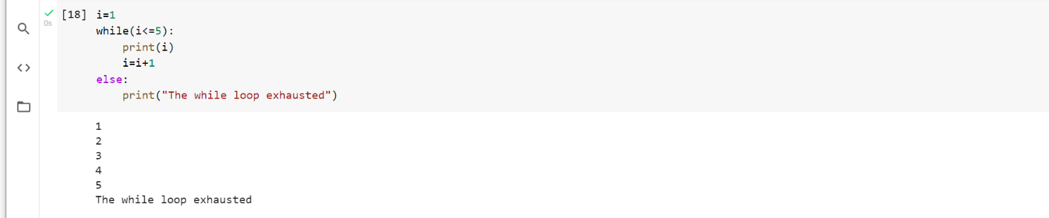

### i=1 while(i<=5):

print(i) i=i+1 if(i==3):

break

else:

print("The while loop exhausted") print("bye bye")

1

2

bye bye

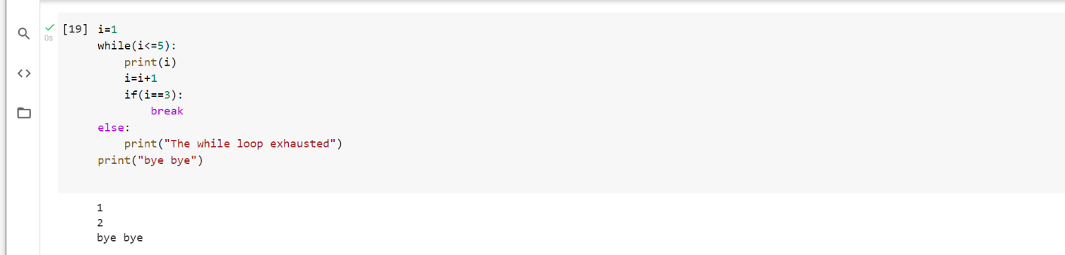

### list =[1,2,3,4] i=1;

count = 1; for i in list:

if i == 4:

print("item matched") count = count + 1; break

print("found at",count,"location");

item matched

found at 2 location

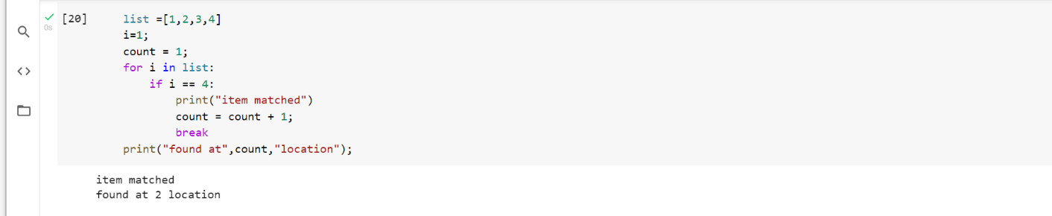

### str = "python" for i in str:

if i == 'o': break

print(i);

p y t h

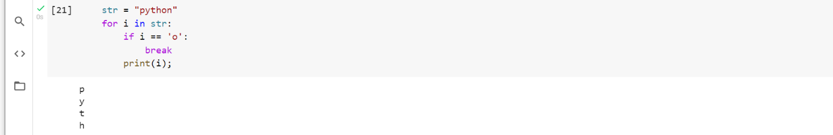

### n=2

while 1:

i=1;

while i<=10:

print("%d X %d = %d\n"%(n,i,n*i)); i = i+1;

choice = int(input("Do you want to continue printing the table, press 0 for no?"))

if choice == 0: break;

continue printing the table, press 0 for no?1

Do you want to continue printing the table, press 0 for no?1 4 X 1 = 4

4 X 2 = 8

|  |  |  |  |  |
| --- | --- | --- | --- | --- |
| 4 | X | 4 | = | 16 |
| 4 | X | 5 | = | 20 |
| 4 | X | 6 | = | 24 |
| 4 | X | 7 | = | 28 |
| 4 | X | 8 | = | 32 |
| 4 | X | 9 | = | 36 |

4 X 3 = 12

4 X 10 = 40

Do you want to continue printing the table, press 0 for no?0

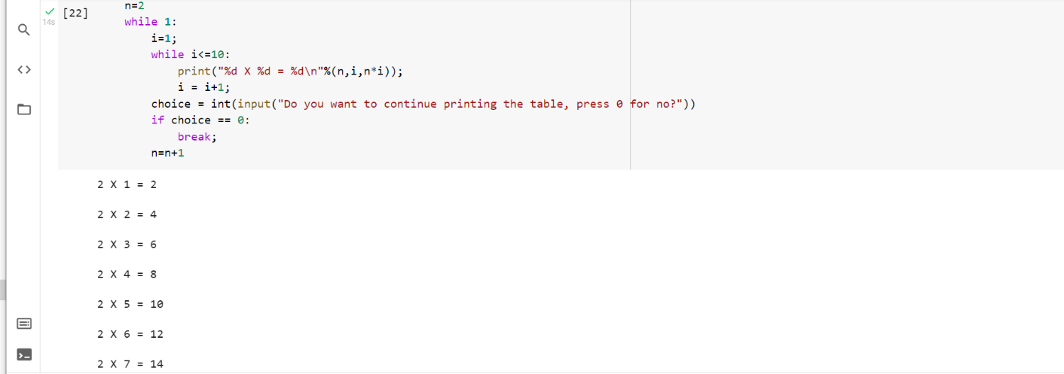

|  |  |  |  |  |
| --- | --- | --- | --- | --- |
|  | | | | n=n+1 |
| 2 | X | 1 | = | 2 |
| 2 | X | 2 | = | 4 |
| 2 | X | 3 | = | 6 |
| 2 | X | 4 | = | 8 |
| 2 | X | 5 | = | 10 |
| 2 | X | 6 | = | 12 |
| 2 | X | 7 | = | 14 |
| 2 | X | 8 | = | 16 |
| 2 | X | 9 | = | 18 |
| 2 X 10 = 20  Do you want to | | | | |
| 3 | X | 1 | = | 3 |
| 3 | X | 2 | = | 6 |
| 3 | X | 3 | = | 9 |
| 3 | X | 4 | = | 12 |
| 3 | X | 5 | = | 15 |
| 3 | X | 6 | = | 18 |
| 3 | X | 7 | = | 21 |
| 3 | X | 8 | = | 24 |
| 3 | X | 9 | = | 27 |
| 3 | X | 10 = 30 | | |

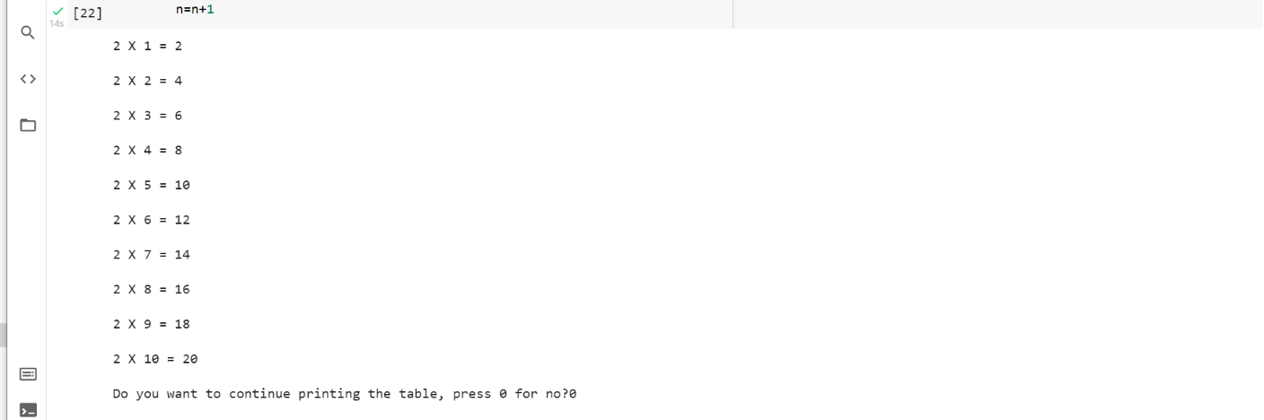

### i = 0

while(i < 10): i = i+1 if(i == 5):

continue print(i)

1

2

3

4

6

7

8

9

10

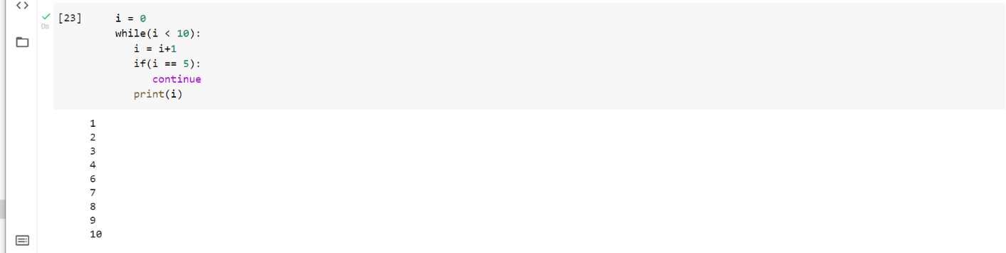

str = "kalyan"

for i in str:

if(i == 'n'):

continue

print(i)

k

a

l

y

a

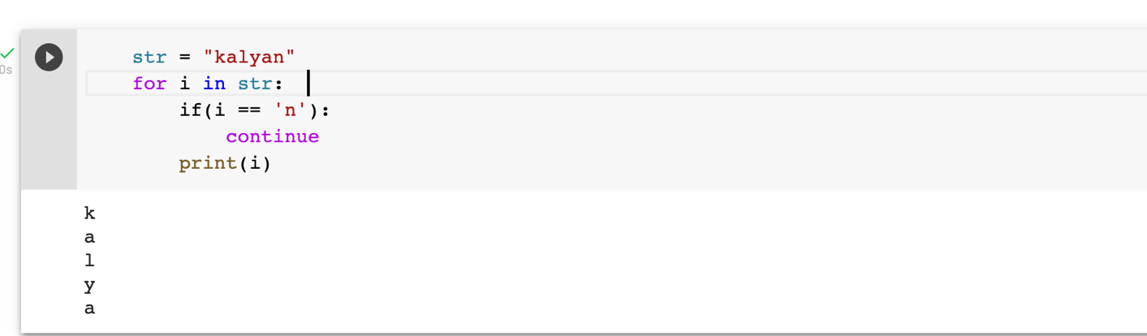

### list = [1,2,3,4,5]

flag = 0

for i in list:

print("Current element:",i,end=" ");

if i==3:

pass

print("\nWe are inside pass block\n"); flag = 1

if flag==1:

print("\nCame out of pass\n"); flag=0

Current element: 1 Current element: 2 Current element: 3 We are inside pass block

Came out of pass

Current element: 4 Current element: 5

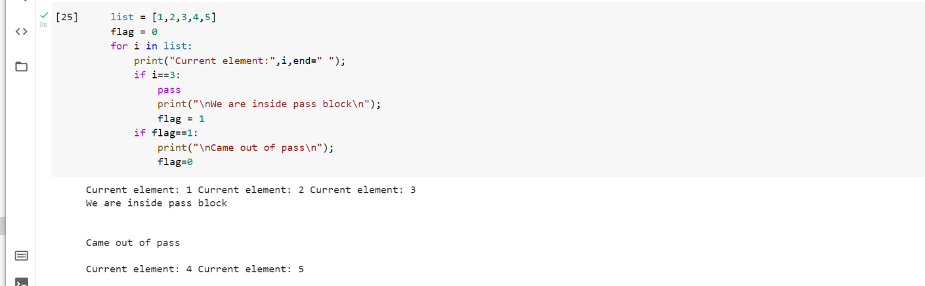

### for i in [1,2,3,4,5]:

if(i==4):

pass

print("This is pass block",i) print(i)

1

2

3

This is pass block 4 4

5

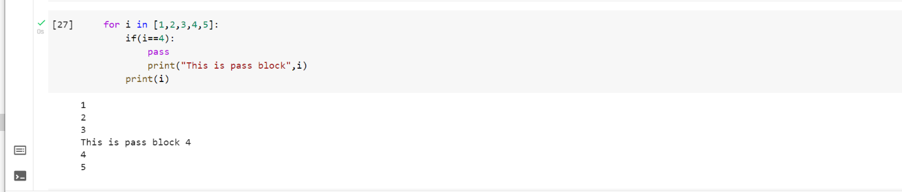

# IF-ELSE

**Program 1**

**Objective:** To check whether the number is Odd or Even using if-else statement

### num = int(input("enter the number?")) if num%2 == 0:

print("Number is even") print("bye")

enter the number?111 bye

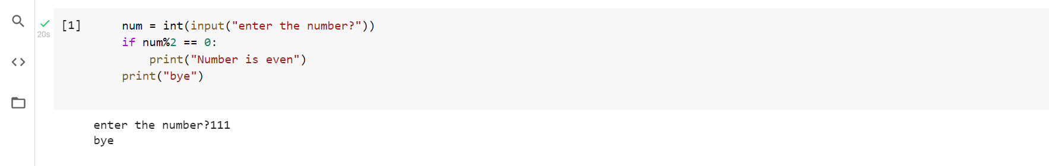

**Program 2**

**Objective:** To check the largest number using if-else statement

### a = int(input("Enter a- "));

b = int(input("Enter b- "));

c = int(input("Enter c- ")); if a>b and a>c:

print("a is largest"); if b>a and b>c:

print("b is largest"); if c>a and c>b:

print("c is largest");

Enter a- 10

Enter b- 20

Enter c- 15 b is largest

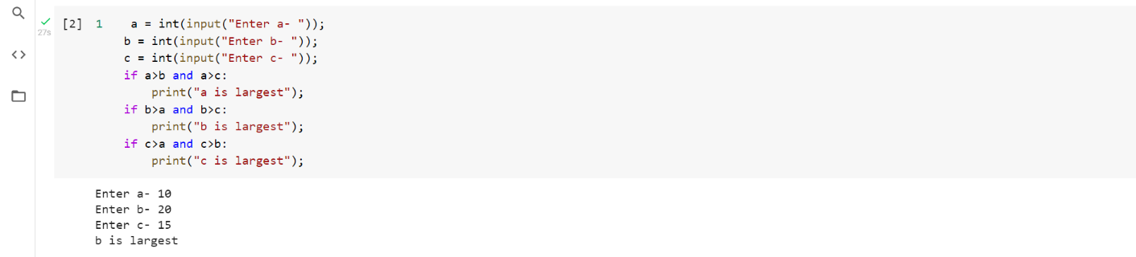

**Program 3**

**Objective:** To check age whether you are eligible for vote or not using if-else statement

### age = int (input("Enter your age? ")) if age>=18:

print("You are eligible to vote !!"); else:

print("Sorry! you have to wait !!");

Enter your age? 23

You are eligible to vote !!

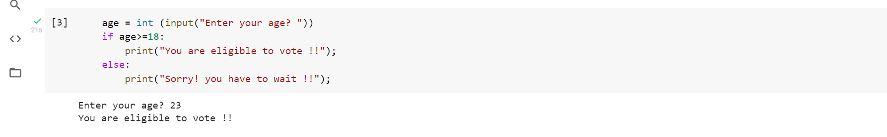

**Program 4**

**Objective:** To check for even or odd number using if-else statement

### num = int(input("enter the number?")) if num%2 == 0:

print("Number is even...") else:

print("Number is odd...")

enter the number?23 Number is odd...

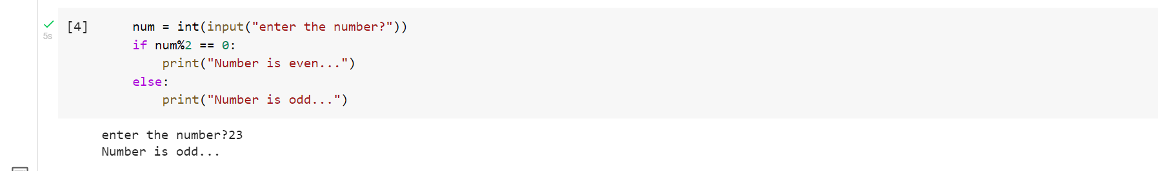

**Program 5**

**Objective:** To check the given number is equal to other numbers or not using if-else statement

### number = int(input("Enter the number?")) if number==10:

print("number is equals to 10") elif number==50:

print("number is equal to 50"); elif number==100:

print("number is equal to 100"); else:

print("number is not equal to 10, 50 or 100");

Enter the number?3435

number is not equal to 10, 50 or 100

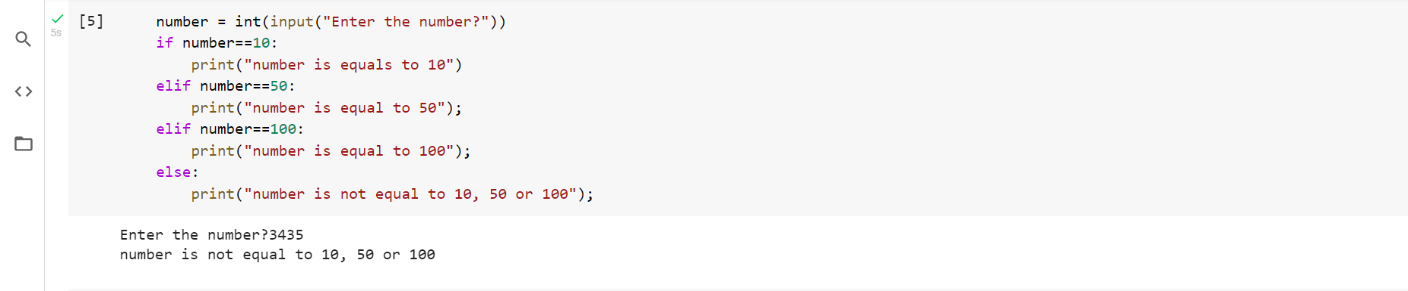

**Program 6**

**Objective:** To check the given number is equal to other numbers or not using if-else statement

### number = input("Enter the number?") if number==10:

print("number is equals to 10") elif number==50:

print("number is equal to 50"); elif number==100

print("number is equal to 100"); else:

print("number is not equal to 10, 50 or 100");

Enter the number?22

number is not equal to 10, 50 or 100

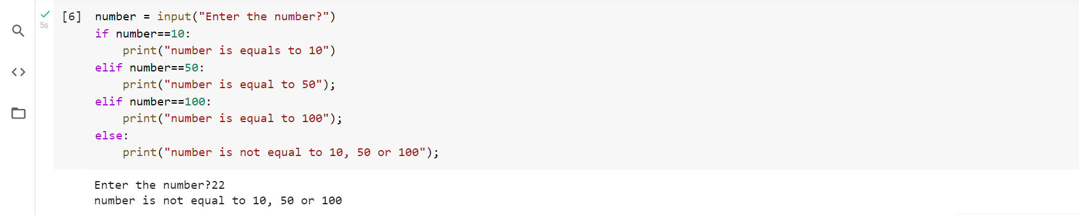

**Program 7**

**Objective:** To check given marks to know the grade using if-else statement

### marks = int(input("Enter the marks? ")) if marks > 85 and marks <= 100:

print("Congrats ! you scored grade A ...") elif marks > 60 and marks <= 85:

print("You scored grade B + ...") elif marks > 40 and marks <= 60:

print("You scored grade B ...") elif (marks > 30 and marks <= 40): print("You scored grade C ...")

else:

print("Sorry you are fail ?")

Enter the marks? 78

You scored grade B + ...

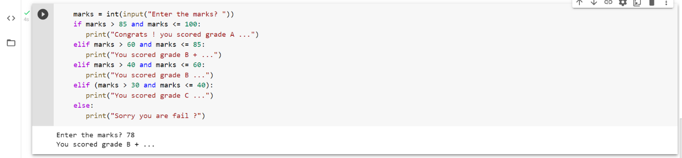

## DICTIONARY’S:

**1)**

dict={'name':'subbu','designation':'student','qual':'btech','univ':'cmr’}

print(dict['name'])

print(dict['qual'])

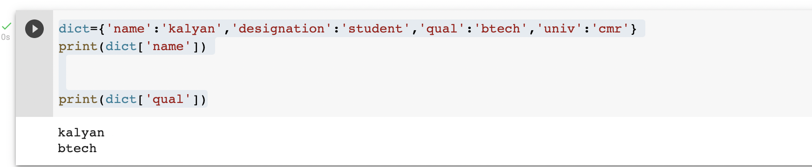

**2)** dict={'name':'subbu','designation':'student','qual':'btech','univ':'cmr'}

dict['name']='subbu'

print(dict['name'])

dict['class']='cse7sem'

print(dict['class'])

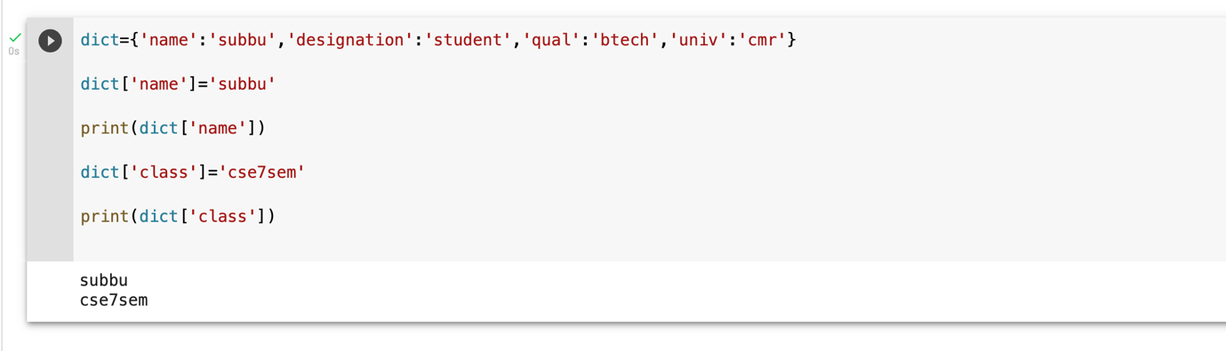

**3)**

dict={'name':'kalyan','designation':'student','qual':'btech','univ':'cmr'}

del dict['designation']

#print(dict['designation'])

dict.clear()

#print(dict['name'])

del dict

**4)**

dict={'name':'subbu','designation':'student','qual':'btech','univ':'cmr', 'name':'tarak'}

print(dict['name'])

print(len(dict))

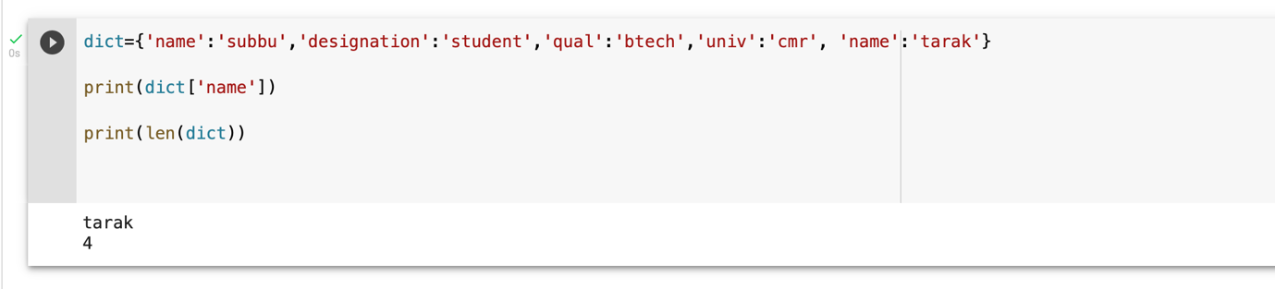

**6)**

dict={'name':'subbu','designation':'student','qual':'btech','univ':'cmr', 'name':'tarak'}

print(dict.values())

print(dict.items())

print(dict.keys())

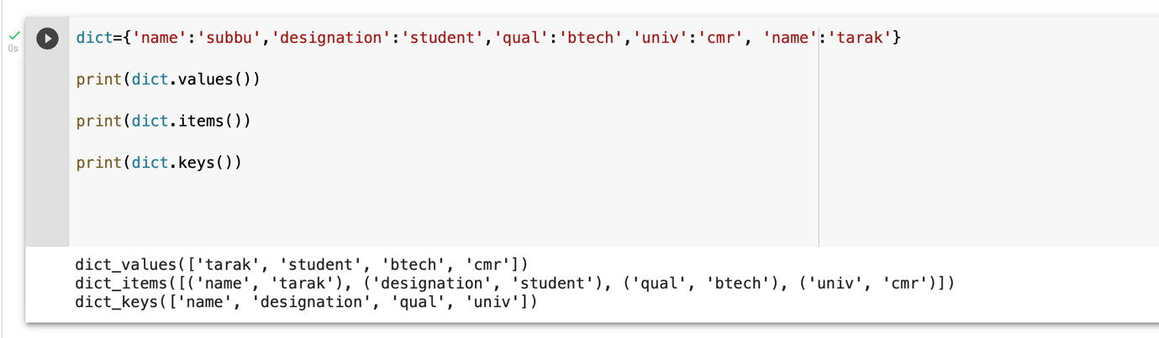

**7)**

dict={'name':'subbu','designation':'student','qual':'btech','univ':'cmr', 'name':'tarak'}

print(dict['name'])

print(dict.get('edu',"nothing"))

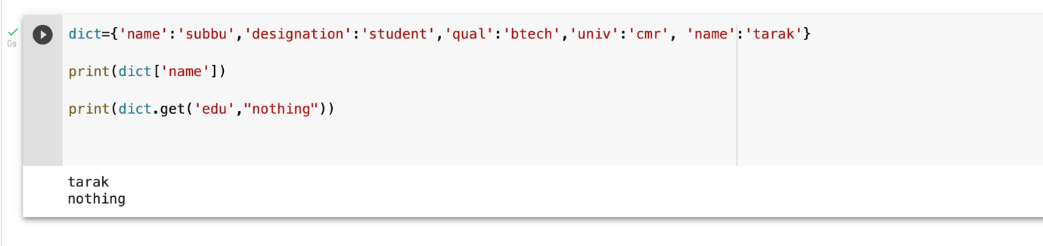

**8)**

dict={'name':'subbu','designation':'student','qual':'btech','univ':'cmr', 'name':'tarak'}

dict2=dict.copy()

print(dict2['name'])

print(len(dict2))

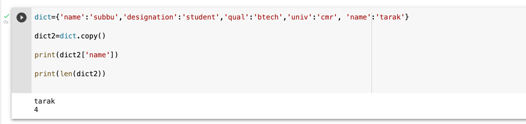

**9)**

dict={'name':'subbu','designation':'student','qual':'btech','univ':'cmr', 'name':'tarak'}

dict2={'edu':'btech-mtech','students':'7sem'}

print(dict)

print(dict2)

dict.update(dict2)

print(dict)

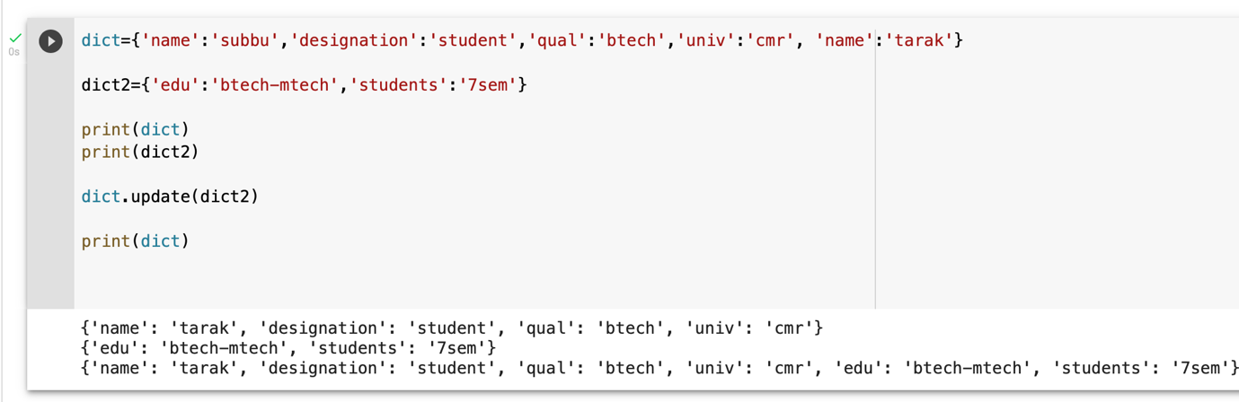

**TUPLES:**

**1)**

tup= ('cse','it','mech')

print(tup)

tup1=(1,23,4,5,5,6)

print(tup1)

tup2="abc","def"

print(tup2)

**2)**

tup1 = ()

print(tup1)

**3)**

tup1 = ()

print(tup1)

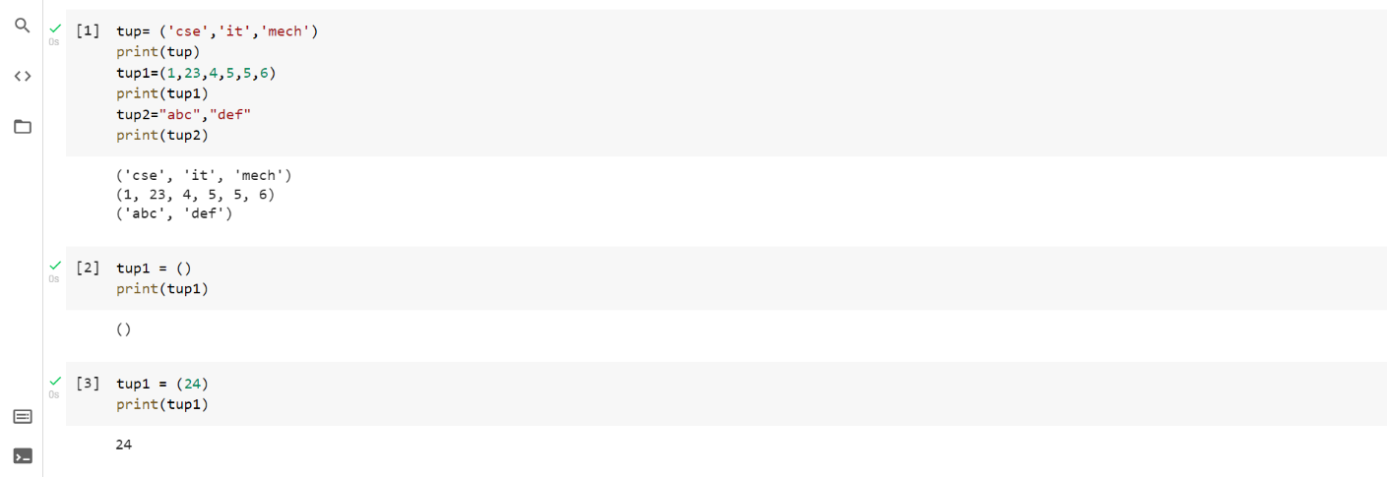

**4)**

tup= ('cse','it','mech','ece','electrical')

print(tup[0])

print(tup[2])

print(tup[2:5])

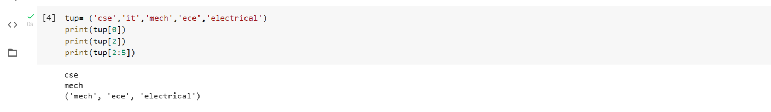

**5)**

tup1= ('cse','it','mech','ece','electrical')

print(tup1)

tup2= ('subbu','tarak','subbu')

print(tup2)

tup3=tup1+tup2

print(tup3)

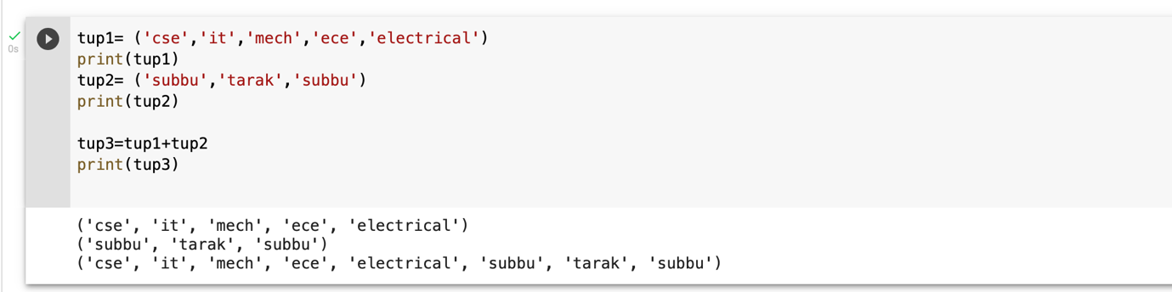

**6)**

tup1= ('cse','it','mech','ece','electrical')

print(tup1)

tup2= ('subbu','tarak','subbu')

print(tup2)

a=len(tup1)

b=len(tup2)

print(a)

print(b)

print(len(tup1))

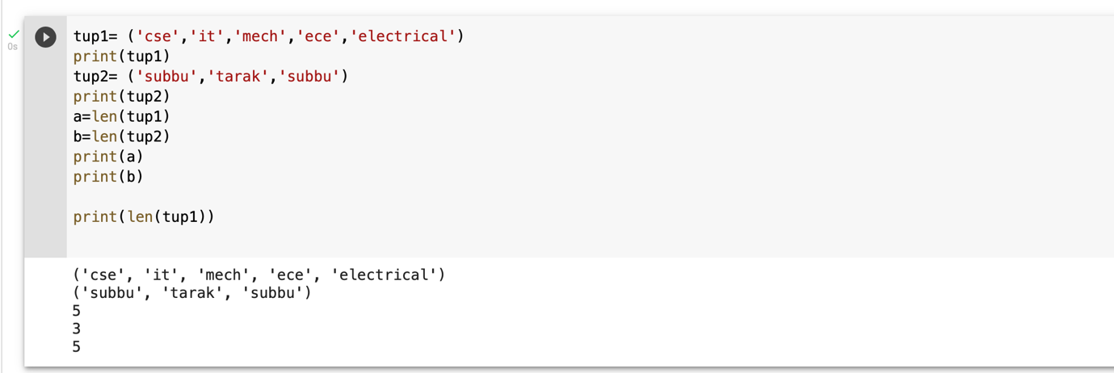

**7)**

tup1= ('cse','it','mech','ece','electrical')

print(tup1)

tup2= ('subbu','tarak','subbu')

print(tup2)

print(max(tup1))

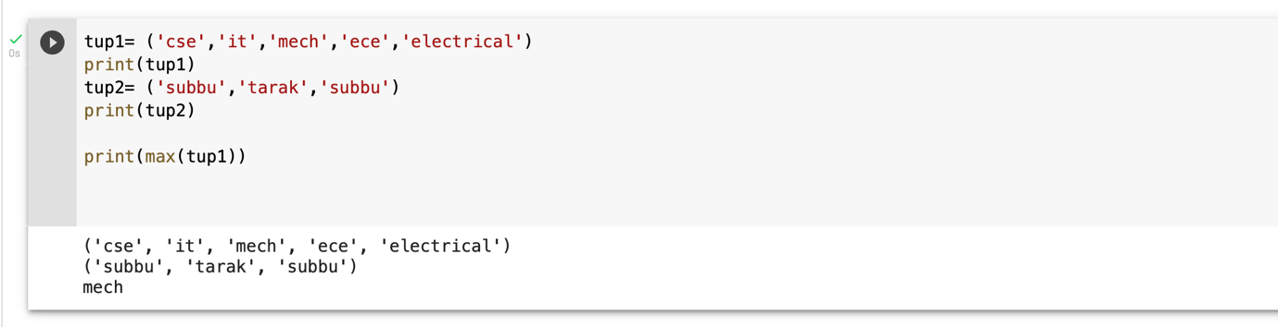

**FILES:**

**PROGRAM 1:**

print ("Python is really a great language,", "isn't it?")

**PROGRAM 2:**

str = input("Enter your input: ")

print ("Received input is : ", str)

**PROGRAM 3:**

# Open a file

fo = open("foo.txt", "wb")

print ("Name of the file: ", fo.name)

# Close opend file

fo.close()

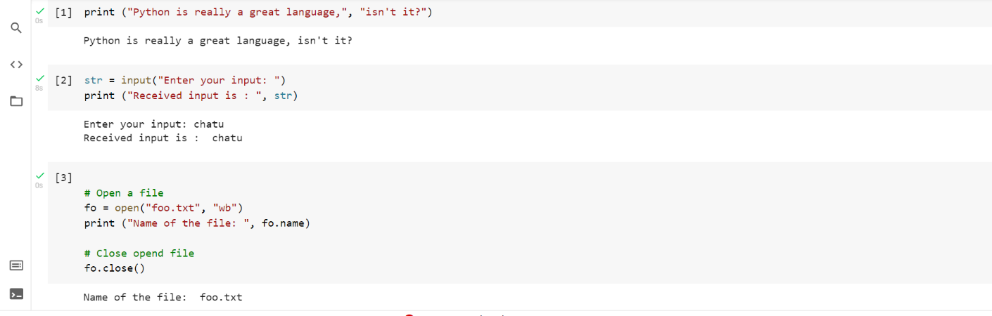

**PROGRAM 4:**

f = open("demofile2.txt", "a")

f.write("See you soon!")

f.close()

#open and read the file after the appending:

f = open("demofile2.txt", "r")

print(f.read())

**PROGRAM 5:**

# Open a file

fo = open("foo.txt", "r+")

str = fo.read(10);

print ("Read String is : ", str)

# Close opend file

fo.close()

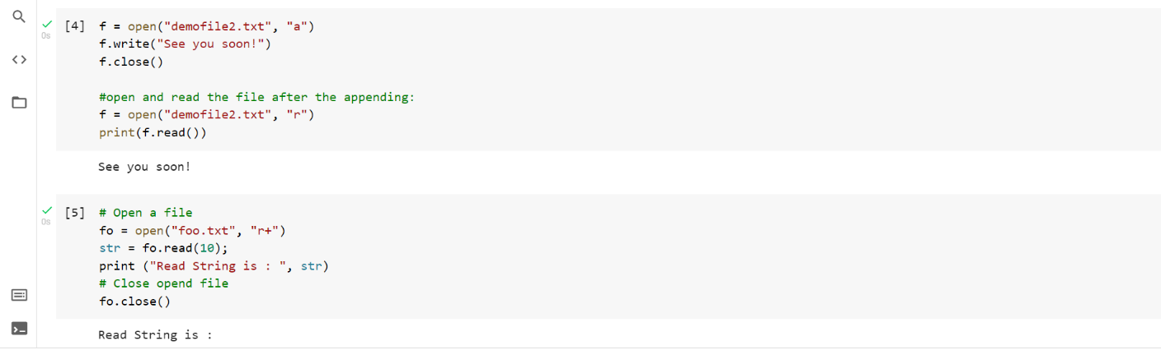

**PROGRAM 6:**

fo = open("foo.txt", "wb")

print ("Name of the file: ", fo.name)

print ("Closed or not : ", fo.closed)

print ("Opening mode : ", fo.mode)

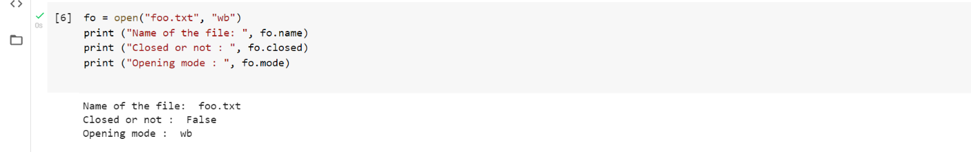

**PROGRAM 7:**

# Open a file

fo = open("demofile2.txt", "r+")

str = fo.read(10)

print ("Read String is : ", str)

# Check current position

position = fo.tell()

print ("Current file position : ", position)

# Reposition pointer at the beginning once again

position = fo.seek(1, 0);

str = fo.read(10)

print ("Again read String is : ", str)

# Close opened file

fo.close()

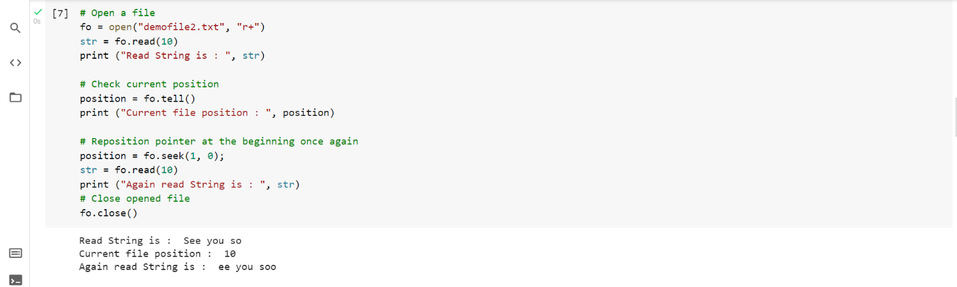

**FUNCTIONS:**

**PROGRAM 1**

def hello (str):

print("in function " + str)

print("after printing in function definition")

return;

print("1")

print("2")

hello("subbu")

hello(“tarak")

print("3")

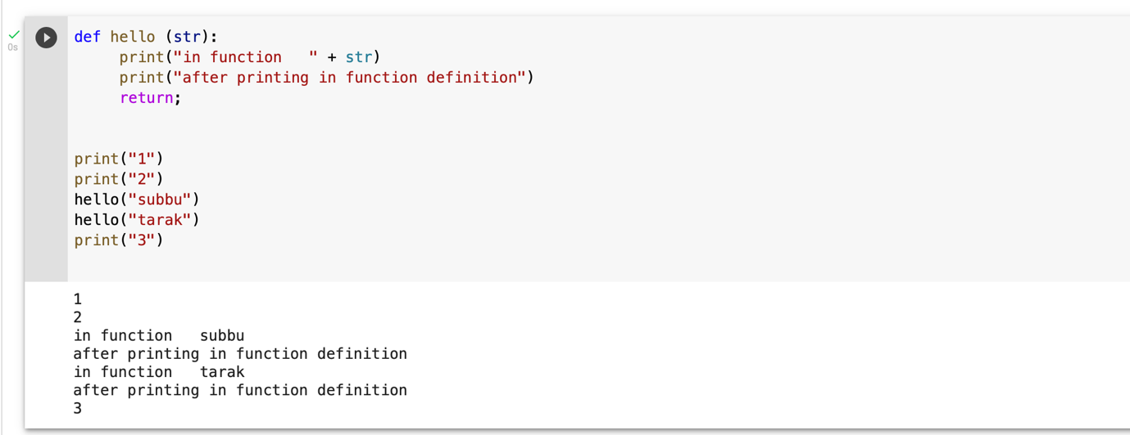

**PROGRAM 2:**

def changeme( mylist ):

   mylist.append([1,2,3,4]);

   print ("Values inside the function: ", mylist)

   return;

mylist = [10,20,30];

changeme( mylist );

print ("Values outside the function: ", mylist)

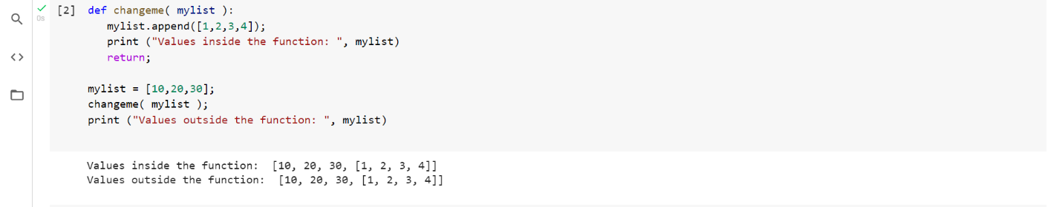

**PROGRAM 3:**

def changeme( mylist ):

    print ("BEFORE CHANGESValues inside the function: ", mylist)

    mylist = [1,2,3,4];

    print ("AFTER CHANGES Values inside the function: ", mylist)

    return

mylist1 = [10,20,30];

changeme( mylist1 );

print ("Values outside the function: ", mylist1)

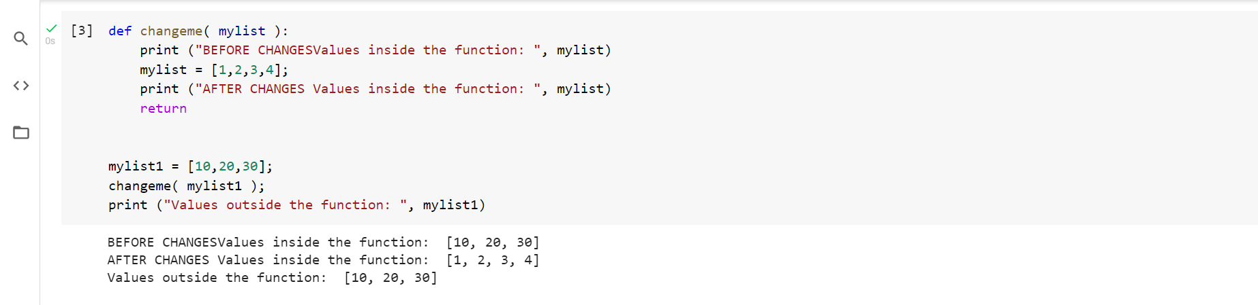

**PROGRAM 4:**

def printme( str ):

     print (str)

     return;

printme( str = "My string")

**PROGRAM 5:**

def printinfo( name, age ):

print ("Name: ", name)

print ("Age ", age)

return;

printinfo( age=20, name="subbu" )

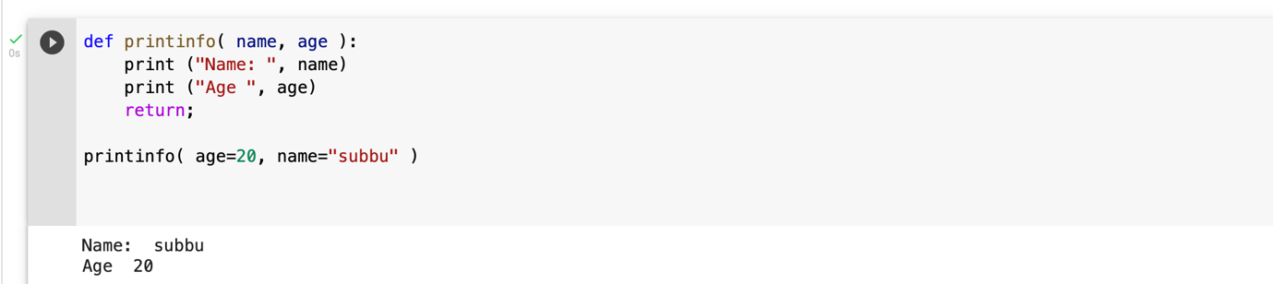

**PROGRAM 6:**

def printinfo( name, age ):

print ("Name: ", name)

print ("Age ", age)

return;

printinfo( "subbu",20 )

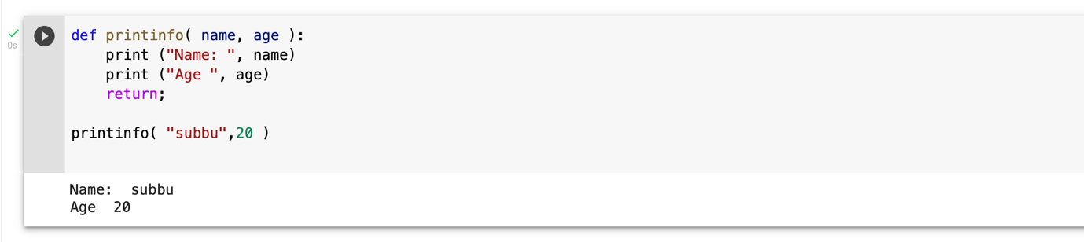

**PROGRAM 7:**

def printinfo( name, age ):

print ("Name: ", name)

print ("Age ", age)

return;

printinfo( 20, "subbu" )

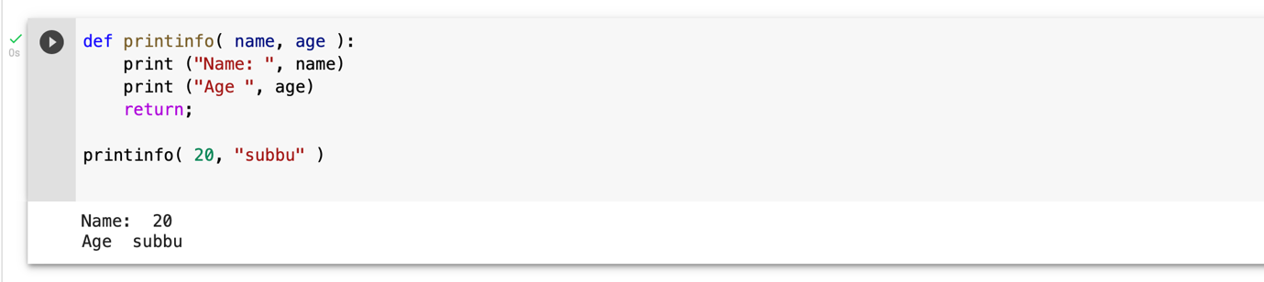

**PROGRAM 8:**

def printinfo( name, age = 19 ):

print ("Name: ", name)

print ("Age ", age)

return;

printinfo( age=20, name="subbu" )

printinfo( name="tarak" )

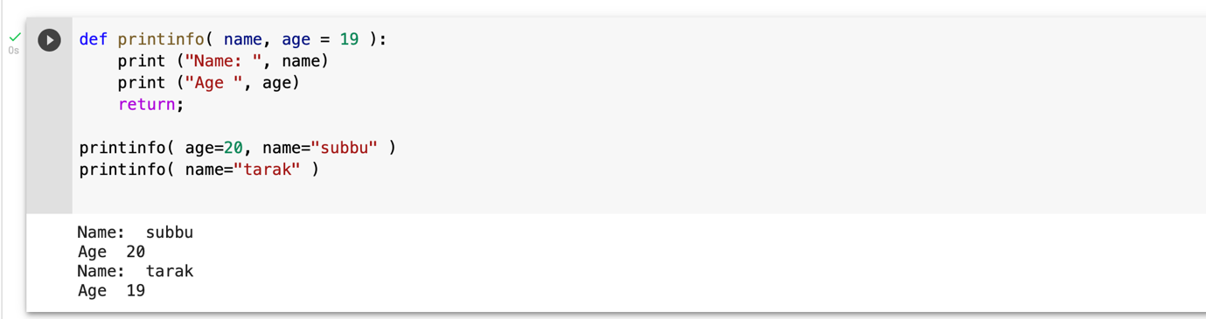

**PROGRAM 9:**

def printinfo( arg1, *vartuple ):

     print ("Output is: ")

     print ("arg1==",arg1)

     for var in vartuple:

        print (var)

     return;

printinfo( 10,78 )

printinfo( 70, 60, 50,90 )

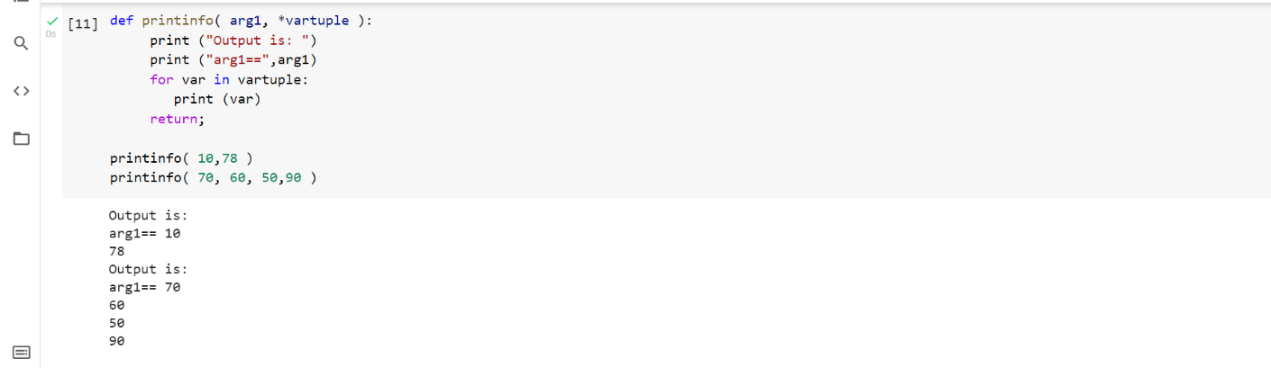

**PROGRAM 10:**

sum = lambda arg1, arg2: arg1 + arg2;

print ("Value of total : ", sum( 10, 20 ))

print ("Value of total : ", sum( 20, 20 ))

**PROGRAM 11:**

def sum( arg1, arg2 ):

    total = arg1 + arg2

    print ("Inside the function : ", total)

    return total;

total1 = sum( 10, 20 );

print ("Outside the function : ", total1 )

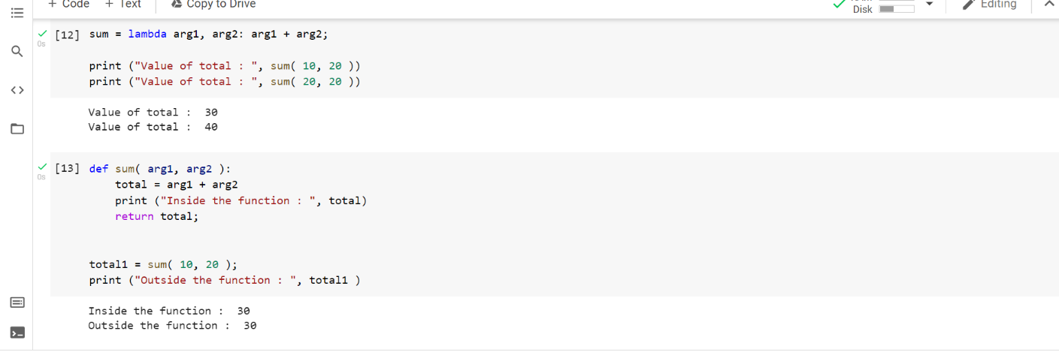

**PROGRAM 12:**

total = 99;

def sum( arg1, arg2 ):

    total = arg1 + arg2;

    print ("Inside the function local total : ", total)

    return total;

sum( 10, 20 );

print ("Outside the function global total : ", total )

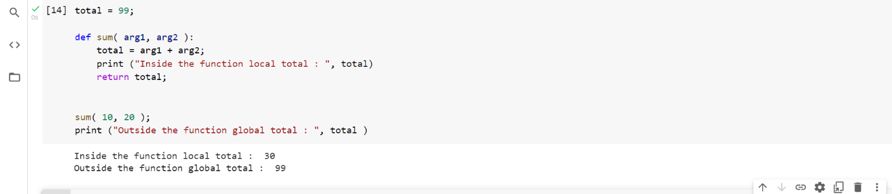

**Program 1**

**Objective:** write a python program for recharge plan for your service provider.

def show():

s = [[str(e) for e in row] for row in h]

lens = [max(map(len, col)) for col in zip(*s)]

fmt = '\t'.join('{{:{}}}'.format(x) for x in lens)

table = [fmt.format(*row) for row in s]

print('\n'.join(table))

def checkInven():

for i in range(1,len(h)):

if(h[i][2]<=5):

print("\nStock replinished")

h[i][2]=20

h=[['Name','Price','Quantity', 'Manufacturer'],['earphone',500,20,'Boat'],['Headphones',1000,15,'Sony'],['Monitor',2500,10,'Logitech'],['MS Office 2021',1000,25,'Microsoft']]

n='a'

cost=0

while(n!='e'):

checkInven()

print("\nStock is\n")

show()

n=input("\np : Buy\nc : Stock\ne : exit\n")

if(n=='p'):

a=int(input("Select an Option (1=earphone, 2=headphone..) "))

if(a>4):

print("Oh no! Seems like you chose wrong option. Try again.")

continue

count=int(input("How many units do you want us to serve you with? "))

if(h[a][2]<count):

print("Sorry.. we're running out of stocks!!")

else:

h[a][2]-=count

print("Thankyou for Shopping")

cost+=h[a][1]*count

elif(n=='c'):

b=int(input("Select an option (1=earphone, 2=headphone..) "))

if(b>4):

print("Incorrect option. Try again.")

continue

print("Stock Left is ",h[b][2])

elif(n=='e'):

pass

else:

print("Oh no! Seems like you chose wrong option. Try again.")

print("\nYour total bill is ",cost,"\nThank you,Visit us Again.")

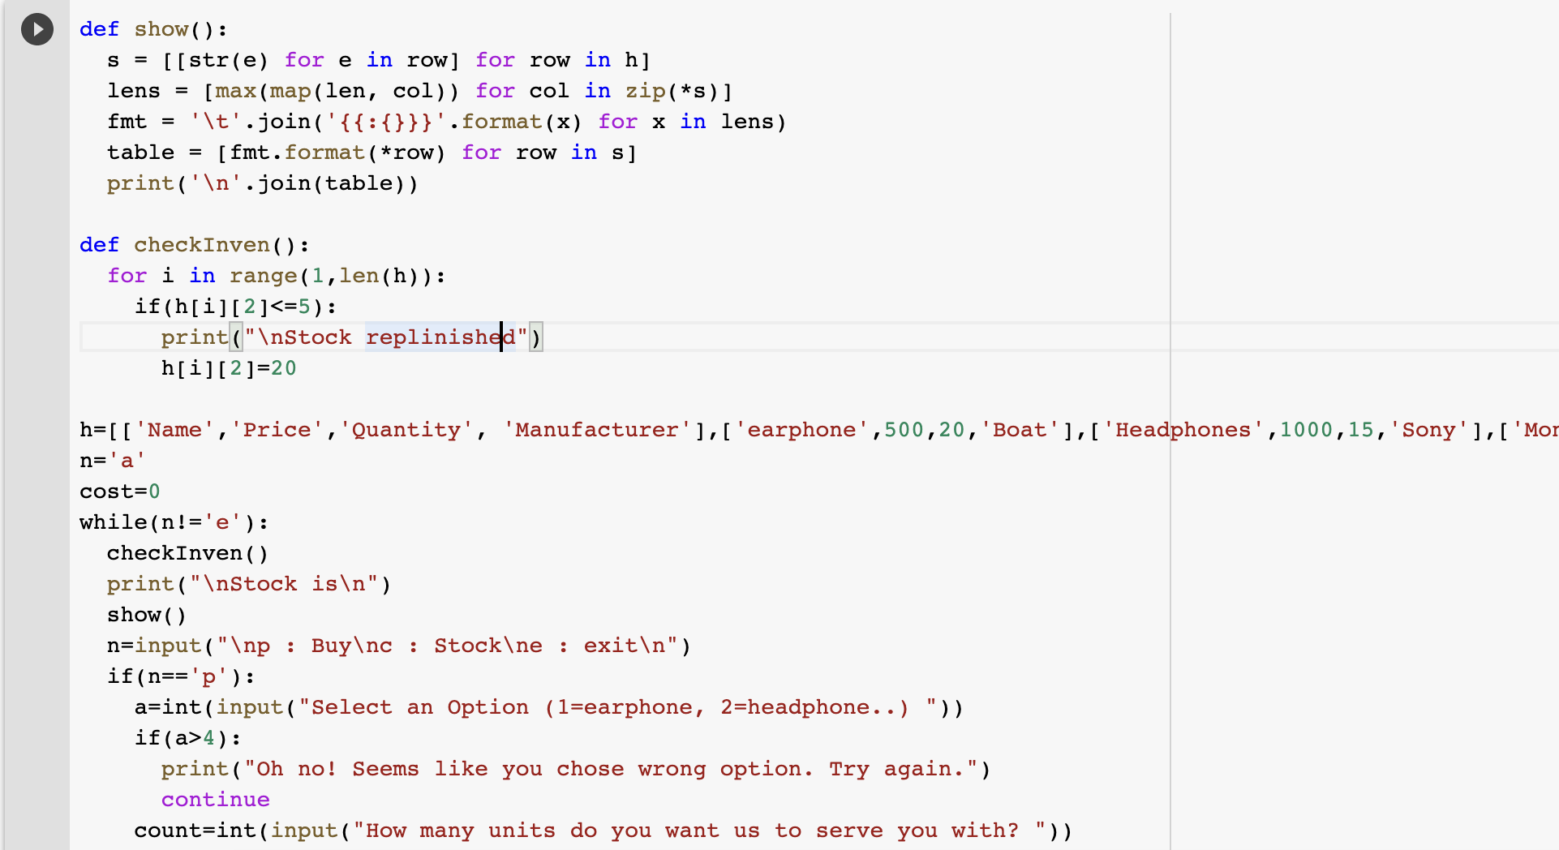

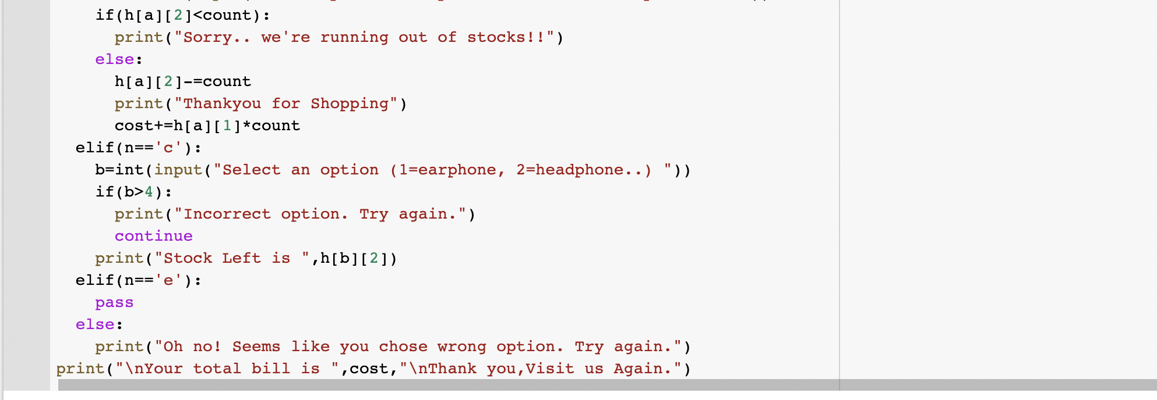

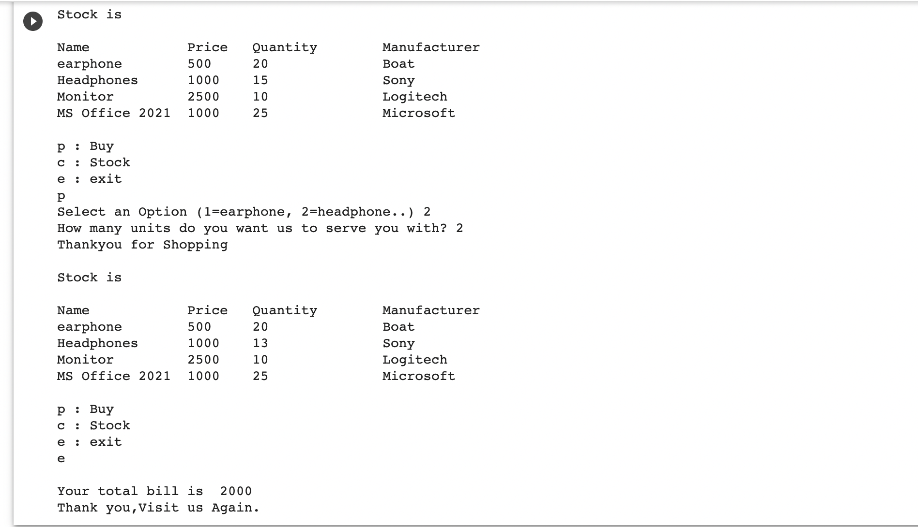

**Program 2**

**Objective:** Design a food delivery application

deli=['Zomato','Swiggy','Behrouz Biryani']

foo=['Pizza','crispy Chicken','Hyderabadi Dum Biryani']

pri=[120,100,200]

repeat='y'

while(repeat!='n'):

user=int(input("1. Zomato\n2. Swiggy\n3. Behrouz Biryani\nEnter your preferred delivery partner "))

choice=int(input("\n1. Pizza : 120/-\n2. crispy Chicken : 100/-\n3. Hyderabadi Dum Biryani : 200/-\nEnter your choice "))

loc=input("\nEnter your address ")

print("\nYour order for",foo[choice-1],"has been placed on",deli[user-1],"and will get delivered",loc,"\nYour Bill for the order is ",pri[choice-1])

repeat=input("Do you wish to order again? (y/n)\n")

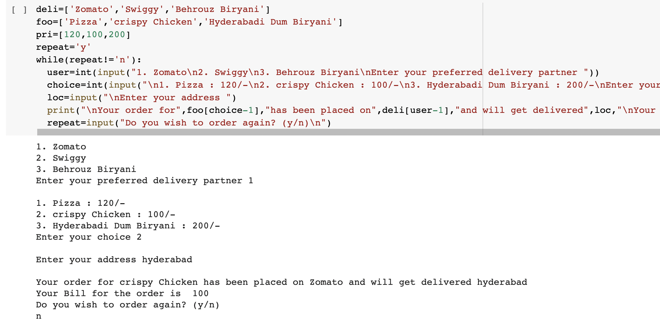

**Program 3**

**Objective:** Design a system for landlord and tenant communication

utilities=input("Enter all bills to be shared separated with a comma\n")

l1=utilities.split(",")

l2=[]

sum=0

n=int(input("Enter no. of tenants "))

n+=1

for i in range(len(l1)):

print("Enter total amount for",l1[i],"bill ")

l2.append(float(input()))

for i in range(len(l1)):

sum+=round(l2[i]/n,2)

print("The",l1[i],"bill is split as",round(l2[i]/n,2),"per head")

print("\nThe total per head is",sum)

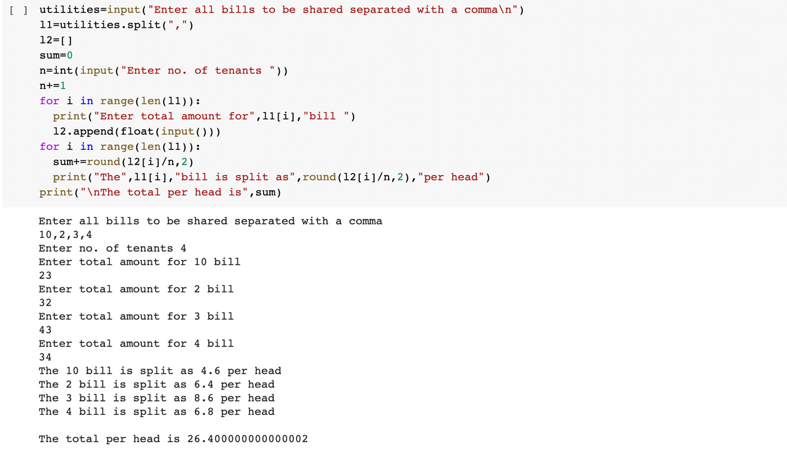

**Program 4**

**Objective:** Design an inventory system

ch=str(input("\"Do you want to recharge?\n Y-Yes and any key-No"))

if ch=='Y' or ch=='y':

opt=int(input("Press 1 for prepaid and any key for postpaid"))

if opt==1:

no=int(input("Enter mobile no"))

operator=int(input("Choose your operator\n1. Jio \n2. Airtel\n3.Vi"))

amt=int(input("Choose a recharge amt\n399 : 1.5 GB data/day for 84 days\n 299 : 1 GB data/day for 56 days\n 199 : 1 GB data/day for 30 days"))

confirm=int(input("Press 1 to confirm and any key to cancel"))

if confirm==1:

print("Your recharge for no {} for amt {} has been succesfull!".format(no,amt))

